Region 2
PIHP/CMH Provider Network Management
Collaboration Guide

Contents
Disclosures of Ownership 2
Regional Contract Boilerplates 5
Agreement Type Selection 7
Code Crosswalk 8
Insurance Guide 9
Out of State Providers 11
Indiana 11
Ohio 14
Wisconsin 15
Master Contract Flow through PIHP to CMH 17
Reciprocity Initiatives 27
Hospital (LPHU) Contracts 34
Common CMH Contracting Questions 37

Disclosures of Ownership

- Background
NMRE and its partner CMHs must comply with federal regulations to obtain, maintain, disclose, and furnish required information about ownership and control interests, business transactions, and criminal convictions as specified in 42 CFR §455.104–106. NMRE and its partner CMHs are required to collect disclosure of ownership, controlling interest and management information from providers that participate in the Medicaid and/or the Children’s Health Insurance Program (CHIP) managed care network pursuant to a Medicaid and/or CHIP State Contract with the State Agency and the federal regulations set forth in 42 CFR Part §455. Required information includes: 1) the identity of all owners and others with an ownership or controlling interest; 2) certain business transactions as described in 42 CFR §455.105; 3) the identity of managers and others in a position of influence or authority; and 4) criminal conviction, sanction, exclusion, debarment or termination information for the provider, owners, and managers. The information required includes, but is not limited to, name, address, date of birth, social security number (SSN) and tax identification (TIN).
Completion and submission of this Statement is a condition of participation in the Medicaid and/or CHIP managed care network and is a contractual obligation with NMRE (PIHP) for services to members under Medicaid and CHIP benefit plans. Failure to submit the requested information may result in denial of a claim, a refusal to enter into a provider contract, or termination of existing provider contracts.
*NMRE maintains policies and practices that protect the confidentiality of personal information, including Social Security numbers, obtained from its providers and associates in the course of its regular business functions. NMRE is committed to protecting information about its providers and associates, especially the confidential nature of their personal information.

- Template Types and Use
The NMRE annually reviews three DOO templates based on CFR 455.104:
- Disclosing Entity DOO
Disclosing entity means: a Medicaid provider (other than an individual practitioner or group of practitioners), or a fiscal agent.
Examples: AFC Type A (provider owned) and B, CLS, Personal Residential Home, Crisis Residential, LPHU (hospital), Respite and respite camp
- Managers and Board DOO
Manager and Board member means a board member or managing employee (CEO, CFO, CIO, etc.) with a control interest in the organization.
The Managers and Board DOO is to be completed by board members of the NMRE, managing employees of the NMRE (CEO, CIO, CFO).
- Subcontract DOO
Subcontractor means -
(a) An individual, agency, or organization to which a disclosing entity has contracted or delegated some of its management functions or responsibilities of providing medical care to its patients; or
(b) An individual, agency, or organization with which a fiscal agent has entered into a contract, agreement, purchase order, or lease (or leases of real property) to obtain space, supplies, equipment, or services provided under the Medicaid agreement (Especially as these approach $25,000 per 12 month period or 5% of the provider’s operating expenses).
Subcontract DOOs are completed for any subcontractor not currently participating with Medicare or CHIP programs where there is a certainty or possibility that that a single significant business transaction (exceed the lesser of $25,000 and 5% of total operating expense) will occur over a period of 5 years, or where the total sum of business transactions shall exceed $25,000 over a 12 month period.
Examples: Professional Individual or Group (not required by CFR but PIHP recommended), Applied Imaging provider, large-scale software supplier, claims TPA
*Physician and health care professional members of a group practice that are credentialed or enrolled into the Medicaid or CHIP managed care program by NMRE (PIHP) or by a delegate of NMRE (PIHP) must submit a signed Individual Provider Statement attesting to the requirements under these regulations at the time of credentialing, enrollment, or contracting, if requested by NMRE (PIHP) or by a delegate of NMRE (PIHP). Any members of a group practice that have an ownership or controlling interest in that Provider as identified below, or is related to another owner or person with controlling interest in that Provider, must submit a signed Individual Provider Statement.

- When to Obtain

- New Disclosures of Ownership need to be obtained:
- Every three (3) years
- At the renewal of the contract
- Any time there is a revision to the information, change in ownership, or upon a request for updated information.
- Within 35 days of a request for this information by the Medicaid Agency (MDHHS).
*DOOs do not need to be collected for landlords, whether receiving <$25,000 or not
*Individual practitioners and groups of practitioners are not disclosing entities and do not need to submit DOOs (as Mediciad already has their ownership information)

- Adding to Monthly Exclusions Checks
Given that the DOO Templates NMRE has adopted will have the below sections:
II. Provider Ownership Information where individual owners and corporate entities have ownership
III. Ownership in other Providers and Entities (will be the same individuals in Section II)
IV. Subcontractor Ownership if they have a direct or indirect ownership of 5% or more in any subcontractor,
V. Family Relationships, the names of any individuals in sections II or IV are related to another person listed on the DOO as a spouse, parent, child of sibling(will be the same individuals in Section II)
VI. Criminal convictions, if the provider or any person with ownership or control has ever been convicted of a federal offense as defined in the DOO (will be the same individuals in Section II)
VII. Business Transactions. If the provider has had any transactions over $25,000 with a subcontractor in the previous 12 months
VIII. List of their managing employees

In addition to Sections G. Debarrment and Suspension and R. Program Integrity (11) of the PIHP Master contract,

42 CFR 1001.1001 states that the OIG may exclude an entity:
(1) If a person with a relationship with such entity—
(i) Has been convicted of a criminal offense as described in sections 1128(a) and 1128(b)(1), (2), or (3) of the Act;
(ii) Has had civil money penalties or assessments imposed under section 1128A of the Act; or
(iii) Has been excluded from participation in Medicare or any State health care program, and
(2) Such a person has a direct or indirect ownership or control interest in the entity, or formerly held an ownership or control interest in the entity but no longer holds an ownership or control interest because of a transfer of the interest to an immediate family member or a member of the person's household in anticipation of or following a conviction, imposition of a civil money penalty or assessment under section 1128A of the Act, or imposition of an exclusion.

Additionally, 42 CFR 420.201 defines a subcontractor as: Subcontractors are
(1) An individual, agency, or organization to which a disclosing entity has contracted or delegated some of its management functions or responsibilities of providing medical care to its patients; or

(2) An individual, agency, or organization with which an intermediary or carrier has entered into a contract, agreement, purchase order or lease (or leases of real property) to obtain space, supplies, equipment, or services provided under the Medicare agreement.

As such, any individual or organization holding ownership in the entity submitting the DOO must be added to monthly exclusion searches. As sections III, V, and VI will be the same individuals listed in Section II, Section VII submissions will not actually hold ownership or control in the organization and are not required at the time of contracting, and Section VIII is a list of individuals exercising control over the operations of the provider as employees, any individual or entity listed in sections II, VII, and VIII should be added to monthly checks. This is owners, managing employees, and subcontracted entities with potentially delegated functions.

- File Locations
The DOO Templates NMRE has adopted in #2 above are located on NMRE’s internal drive in the Provider Network folder and are made public to its partner CMHs via TEAMS. Important: To adopt the NMRE DOO, a CMH must change

- Navigate to “NMRE Regional Groups”, Click “Provider Network”
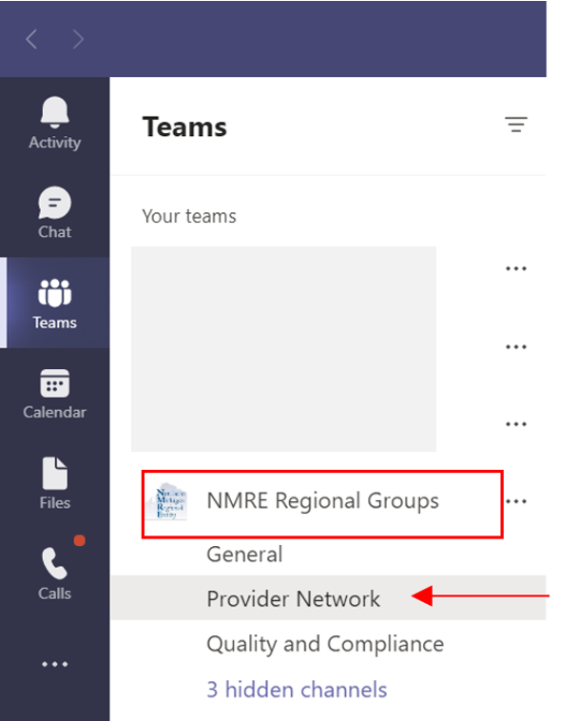

- At the top of Provider Network TEAM, click files

- DOO Templates are in the DOO Templates folder in the current fiscal year
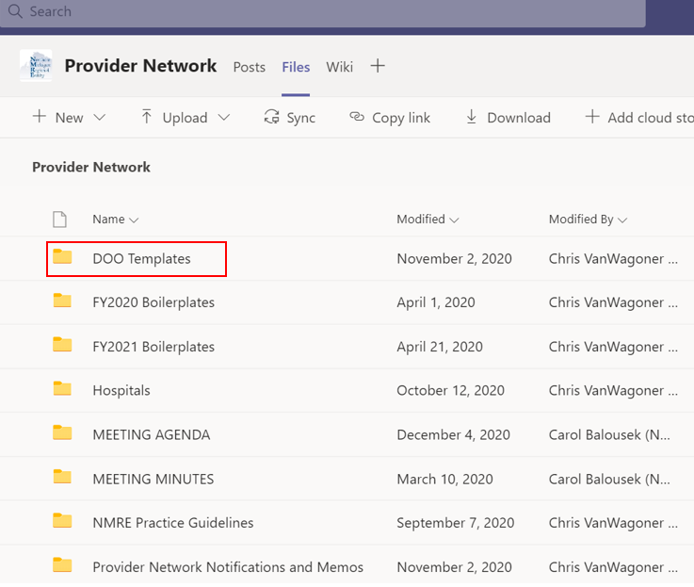

- Confidentiality – Region 2 does NOT share DOOs

“Why can the NMRE not collect disclosures of ownership and distribute to our CMHSPs?”
First and foremost, the NMRE, via its subcontracts with its partner CMHSPs, contractually obligates the (MH) provider network management and development functions. Your provider network is your provider network; and as the NMRE does not hold contracts which pass along the requirements of 42 CFR 455.104-106 with your providers, it is not appropriate for us to collect personally identifiable information from them. We have access to it via monitoring…but do not collect it.
In addition, on page 25 of the attached Medicaid Enrollment Compendium, updated April 2025, under section A General Requirements, “in an effort to mitigate the risk that PII will be compromised in a data breach, we further believe the SMA should store PII in the fewest number of locations necessary to meet the requirement of the regulations at Subparts B and E.”
Interpretation of the language in this section, as well as best practices to ensure provider confidentiality, resulted in the Region 2 Operations Committee to approve a Disclosure of Ownership policy in February of 2019 which removes NMRE collection of DOOs on behalf of its partner CMHSPs.
*If a provider sends a CMHSP a disclosure that is NOT the Region 2 approved template, you must make best efforts to obtain the Region 2 approved version, as the Provider Network Committee has vetted this template to ensure compliance with 42 CFR 455.104-106. Auditors may accept disclosures from other agencies but there is no way to guarantee their template contains the required information, and may result in citations and corrective actions, etc.

Regional Contract Boilerplates

Regional Boilerplates currently exist in TEAMS for the following contract types:

- Administrative Services
- Camp Letter of Agreement
- Children Crisis Residential
- CLS/Respite Services
- COFR Contract
- Crisis Residential
- Children’s Therapeutic Foster Care
- Drop-In services
- Fiscal intermediary
- Generic Goods and Services
- Independent AFC Placements (Type A)
- Letter of agreement with and without HIPAA clause
- Licensed AFC (Type B)
- Professional Group
- Professional Individual
- Supported Independent Placements

Location in TEAMS:
In NMRE Regional Groups, enter the “Provider Network” team
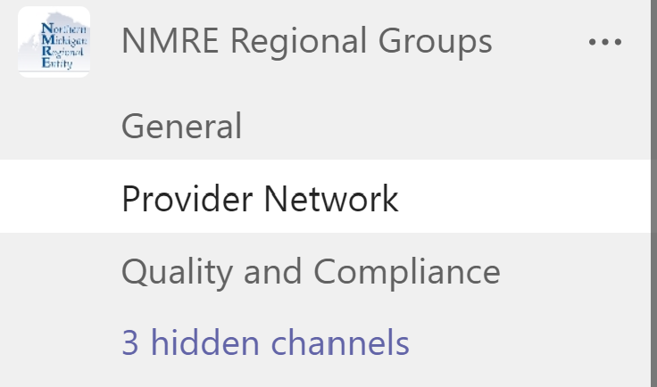
In the Provider Network, click “files” at the top
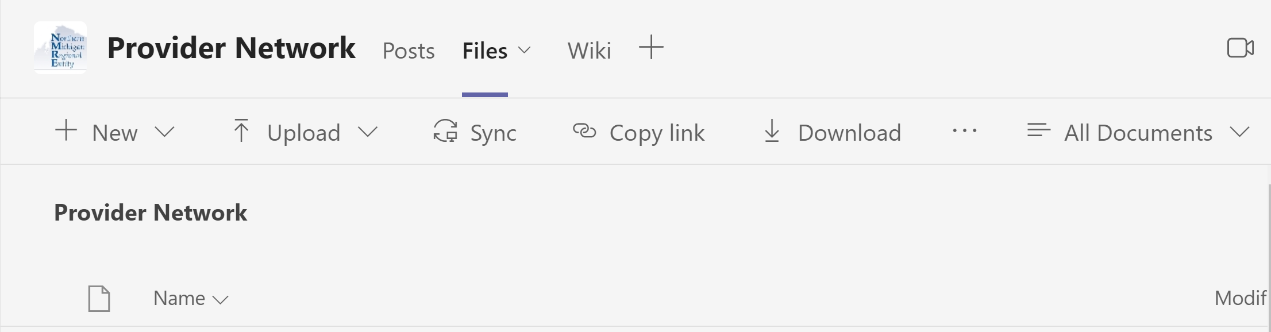
In the files screen, click “Annual Behavioral Health Boilerplates”

Select the applicable fiscal year


Agreement Type Selection
When to use: Memoranda of Understanding
Business Associate Agreements
Purchase Orders
Administrative Contracts

Memoranda of Understanding
MOUs are used where the need is to define the functions only of both parties on each side of an agreement; there may not necessarily be a data or financial transactions involved. For CMHs, MOUs are typically used with other county agencies (judiciary branch, sheriffs, county governments, ISDs). To ensure regulatory compliance, especially if there is a dollar exchange which may exceed $5,000, Administrative Services Contracts should be used rather than purchase orders or MOUs (2 CFR 200.313, 2 CFR Part 200, Subpart E – Cost Principles, 200.436 and 200.439).

Business Associate Agreements
BAAs are typically between healthcare providers and will not usually contain exchange of dollars; BAAs are generally only put in place to cover HIPAA requirements when there is a transfer of confidential data. These are often executed in situations where parties need to exchange PHI for further consideration prior to executing procurement contracts, or are used in situations where the only transaction is data transfer (for this reason, BAA Exhibits can also usually stand by themselves). It is not necessary that every service contract contain or be proceeded by BAA provisions; it is generally advisable to include BAAs only when appropriate for stand-alone data transfer to protect PHI (such as for auditors, cleaning personnel, etc.). If there is an exchange of dollars in consideration as well, an administrative contract should be used rather than a BAA.

Purchase Order
Where purchases will be less than $5,000, and there is a low risk of publicly funded fraud/waste/abuse, and the nature of the agreement will be for administrative services (requests for additional staff funding or home modifications, ad hoc pay-as-you-go services, etc), it may be appropriate to use purchase orders. Typically, these are shorter term or one-time agreements; CMHs should exercise due diligence to attempt administrative contract execution when costs may creep close to the $5,000 mark or it the agreement will be ongoing. In addition, CMHs need to be mindful of the transparency of its procurement requirements…the PIHP, MDHHS, other auditors of public funds, etc., will want to see that purchases are completed in compliance with the law and contractually (note to review procurement policy compliance, audit and compliance examination results, etc.). Ultimately, the assumption of weighing risks of using purchase orders will be up to the CMH.

Administrative Service Contracts
In agreements where consideration involves an exchange of dollars, the CMH should attempt to complete administrative contracts. This is especially true when the cost may get close to the $5,000 mark. This may be snowplowing, janitorial, etc. If the dollar amount will exceed $25,000, the CMH should also be collecting a Disclosure of Ownership (42 CFR 455.105). The administrative contract will address items likely not included in BAAs, PO’s, or MOU, such as: solvency, applicable law and venue, nondiscrimination, conflict of interest, monitoring, relationship of parties, DOO (as applicable), and generally do a better job addressing contractual elements overall.

Code Crosswalk

Professional Individual | Individual Licensed Professionals (Social worker's, Applied Behavior Analysts, Psychologist, Psychiatrists) | all associated codes
Professional Group | Organization with Licensed Professionals (Social worker's, Applied Behavior Analysts, Psychologist, Psychiatrists), CMH's (COFR), Austim Providers | all associated codes
Personal Residential Home | PRH, SIP, In Home Community Living Supports | H2015 (and modifiers)
Independent AFC Placements Licensed Type A (Provider Owned) | Licensed Residential (Independent placement) | H2016, T1020
Independent AFC Placements Licensed Type B | Licensed Residential | H2016, T1020
Fiscal Intermediary | Fiscal Intermediary | all associated codes
CLS/Respite | Community Living Supports, Respite | H2015, T1005, S5151, H0045 (and modifiers)
Crisis Residential | Crisis Residential | H0018 (and modifiers)
Administrative Services | Maintenance, Lawncare, Snow removal, Shredding, Recycling, Pharmacy (Med box administration or enhanced pharmacy), clerical support | T1999

Insurance Guide

Definitions

Certificate of Insurance (COI). The certificate of insurance is the documents that provides the policy exists. It does not amend details of coverage; it merely provides coverage limits, the insurance provider, policy number, and names insureds for an effective time period.
Policyholder. The policy holder is the person or entity that has purchased the policy from the insurance provider. The policyholder provides copies of their COI to contractors that require it, such as a CMH...making the CMH the Certificate Holder.
Certificate Holder. Certificate holders obtain copies of the COI and gain no benefits from the policy; they are simply the parties that contractually require copies of a subcontractor’s COI.
Additional Insured. An additional insured is a provision on the COI’s commercial general liability policy that extends the coverage of the policyholder to a client or other parties. The policyholder could name specific additional insureds, or blanket insureds for certain groups. This could extend the coverage of a CMH provider to a provider’s subcontracted entity providing vendor services on the provider’s behalf.
Interested Party/Party of Interest/Additional Interest: A party interested in the status of the insurance, who receives updates upon the status for changes and cancellations.

Residential Home Insurance

Three coverage types: individuals onsite.
- General Liability – Covers the premises and bodily or personal injury or property damage from normal business operations
- Professional Liability – Relates to the care provided to residents.
- Abuse and Molestation

Factors Effecting Rates:
Location
Square footage
Number of beds
Number of employees or care workers.

*Note that coverage amounts are NOT above major factors to rate calculation

Coverage limits:

$1M/$2M vs $1M/$3M vs $2M/$5M
Current industry coverage limit standards are $1M per occurrence and $3M aggregate; umbrella policies may be purchased to increase coverage limits. Most homes will be safe financially within these limits; however, it would be up to the CMH to consider increasing minimums as the number of beds and staff increases, depending upon location.

Smaller privately owned “mom and pop” providers such as respite camps may request smaller coverage limits such as $1M/$2M; that $1M/$3M is not much more costly and should be pursued with the insurance carrier if possible. Lowering the coverage limits doesn’t necessary lower the premiums substantially; it’s often more advantageous to go with the higher limit.

Note on Property Coverage: For residential homes, property coverage is also required as a commercial policy above homeowner’s insurance. Providers often have coverages such as $500/$1000 for general liability/property insurance…but this alone is not recommended as there is very little coverage for the provider’s business unless they have a commercial general liability provision.

Note on Financial Management Service providers: FMS functions would likely fall under professional liability, possibly with the addition of crime coverage (for handling money).

Note on CMH listing on Insurance Policies: Insurance agent guidance suggests the CMH needs to be specifically listed as an additional insured; being the certificate holder just verifies coverage on the date listed. NMRE and CMH insurance agency, MMRMA, has provided the guidance that while MMRMA does not require providers list NMRE/CMH Payors as additional insured, it would be “a good idea”. This way we would not only receive copies, but we would also have some degree coverage under their policy for their actions. (NMRE’s MMRMA Account Manager, 4.14.21)

Current MDHHS-PIHP Insurance Requirements

Required Limits | Additional Requirements
Commercial General Liability Insurance
Minimum Limits:
$1,000,000 Each Occurrence
$1,000,000 Personal & Advertising Injury
$2,000,000 General Aggregate
$2,000,000 Products/Completed Operations
Professional Liability (Errors and Omissions) Insurance
Minimum Limits:
$3,000,000 Each Occurrence
$3,000,000 Annual Aggregate

*not intended as requirements as pass-though to subcontracted providers

Out of State Providers

Indiana

Family and Social Services Administration, Mental Health Programs and Services Main Page (URL Below)
- Adult 1915(i) Programs
- Projects for Assistance in Transition from Homelessness
- Recovery Works
- State Psychiatric Hospitals
- Medicaid Rehabilitative Option
https://www.in.gov/fssa/dmha/mental-health-services/

Indiana Health Coverage (IHCP) Provider Locator (URL Below)
- Hospital staff only (search by institution)
  - Psychiatric, rehabilitation, inpatient addiction, etc
- Addiction Services
  - Opioid Treatment, SUD Residential
- Behavioral Health
  - ABA Therapists, Community Mental Health Centers, Dietician, Home Health, Hospice, etc
  - Psychiatry, Obstetrician/Gynogology, Pediatrician, Physical Medicine and rehabilitation

https://provider.indianamedicaid.com/ihcp/ProviderServices/ProviderSearch.aspx
Inpatient Psychiatric – Find facility on top URL, verify license on the bottom URL
Indiana Licensing Lookup (search Facilities)
https://mylicense.in.gov/everification/
Indiana Hospital Listing: https://www.in.gov/health/reports/QAMIS/hosdir/index.htm
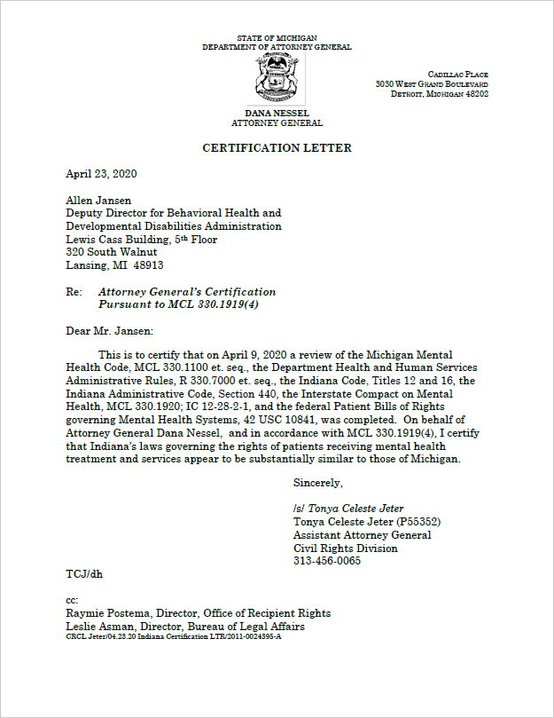

Ohio

(Ohio Department of Medicaid - ODM)

Ohio Department of Medicaid - Find a Provider
https://ohiomh.com/home/findaprovider

Ohio - CMS Hospital Search
https://publicapps.odh.ohio.gov/eid/Provider_Search.aspx

Ohio Hospital Association Member Hospitals (search by “Psychiatric/Behavioral Health”)
https://ohiohospitals.org/About-OHA/Ohio-Hospitals/Member-Hospitals



Wisconsin

(Wisconsin Department of Health Services)

Provider Search
The Provider Search tool gives you an easy and fast way to find a health or residential care provider in Wisconsin. This includes residential care providers. All providers listed are regulated by Wisconsin Department of Health Services (DHS), Division of Quality Assurance (DQA).
https://ohiomh.com/home/findaprovider

Wisconsin Psychiatric Hospitals
This dataset contains locations and attributes of psychiatric hospitals licensed by the state of Wisconsin.
https://data.dhsgis.wi.gov/datasets/wi-dhs::wisconsin-psychiatric-hospitals/explore?location=43.791063%2C-88.383735%2C7.34
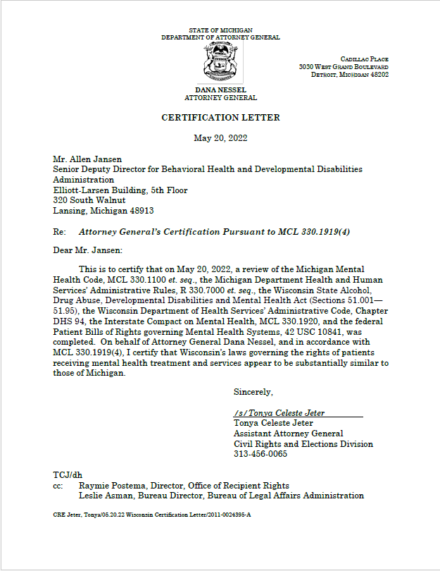

Master Contract Flow through PIHP à CMH
PIHP/MDHHS Contract
10. Subcontracting.
Contractor must: (a) be the sole point of contact regarding all contractual matters, including payment and charges for all Contract Activities; (b) make all payments to the subcontractor; and (c) incorporate the terms and conditions contained in this Contract in any subcontract with a subcontractor. Contractor remains responsible for the completion of the Contract Activities, compliance with the terms of this Contract, and the acts and omissions of the subcontractor. The State, in its sole discretion, may require the replacement of any subcontractor.

PIHP/CMH contract
- Monitoring Processes.
In addition to reports provided to the Payor, as noted in Exhibit D of this Agreement, monitoring shall occur at least annually. Requirements of this delegation shall be monitored during the Payor’s annual site review of the Provider.

CMH Contractually Obligated functions
- Access.
- Contractually Obligated Activities
- The Provider shall ensure access to services comply with the “Access Standards” Attachment to the MDHHS/PIHP Agreement, and timeliness standards comply with Schedule E, Contractor Reporting Requirements for Medicaid Specialty Supports and Service Beneficiaries” of the MDHHS/PIHP Master Contract.
- The Provider shall ensure that its access systems maintain the capacity to immediately accommodate individuals who present with Limited English Proficiency (LEP) and other linguistic needs, diverse cultural and demographic backgrounds, visual impairments, needs for alternative forms of communication, and mobility challenges.
Pursuant to 1.General Requirements; E. Access and Availability; 8 to the MDHHS/PIHP Master Contract
- Performance and Reporting Criteria.

The Provider shall ensure timely access within the standards set forth by the Michigan Department of Health and Human Services for substance abuse services as indicated in the Michigan’s Mission-Based Performance Indicator System. The Provider must monitor its overall performance of individual providers and/or Subcontractors against these standards taking action to improve access to Consumers as indicated.
- Covered services must be geographically accessible to all people within the Provider’s service area.
- Access to screen and referral must be available on a twenty-four-hour (24-hour) basis.
- Non-emergent situations must be assessed face-to-face within fourteen (14) calendar days of referral or presentation, ninety-five percent (95%) of the time. The start of ongoing treatment will occur within fourteen (14) calendar days of assessment, ninety-five percent (95%) of the time.
- Persons discharged from inpatient services must be seen for follow-up treatment within seven (7) calendar days of discharge.
The Provider must monitor its overall performance an the performance of its individual providers against the standards identified in Exhibit D of this Agreement, taking action to continually improve access to Clients.
- Reporting Requirements.
On a quarterly basis, the Provider shall supply data to the Payor necessary to report against the substance abuse performance indicators identified in Michigan’s Mission-Based Performance Indicator System.
- Monitoring Processes.
In addition to reports provided to the Payor, as noted in Exhibit D of this Agreement, monitoring shall occur at least annually. Requirements of this delegation shall be monitored during the Payor’s annual site review of the Provider.
- Sanctions or Corrective Actions Specific to Obligated Function.
In the event that the Provider fails to meet the established criteria for the performance of this obligated function, corrective action will be required in the form of a Corrective Action Plan from the Provider to the Payor.

- Grievance and Appeal.
- Contractually Obligated Activities
  - Enrollee Complaint, Grievance and Appeal, and Second Opinion Process
- The Provider shall have a grievance and appeal system in place for Enrollees that complies with Subpart F of 42 CFR 438.
- The Provider shall supply information about the grievance and appeal system to all its providers and Subcontractors at the time they enter into a contract.
  - Communication
The Provider is responsible for notifying both its staff and Enrolees of:
- The Payor’s complaint, grievance and appeal, and second opinion system.
- Implementation of the Payor’s policies and procedures, related to Grievance and Appeals, and Second Opinion.
- Enrollees’ right to reasonable assistance with completing forms and taking other procedural steps.
- The Provider’s responsibility to produce grievance and appeal acknowledgements, Adverse Benefit Determinations, and disposition notices within the timeframes specified by and in accordance with the Payor’s policies and procedures and the MDHHS/PIHP Master Contract.
- Requirements for documenting and reporting Denials, Grievance and Appeals, Fair Hearings, Recipient Rights Complaints, Second Opinion Requests, Critical Incidents, and Sentinel Events.
- Requirements for documenting and reporting the disposition of all Grievance and Appeals, Fair Hearings, Recipient Rights Complaints, Second Opinion Requests, Critical Incidents, And Sentinel Events.
Pursuant to Section 1.General Requirements; L. Grievance and Appeals and the “Appeal and Grievance Resolution Processes Technical Requirement” of the MDHHS/PIHP Master Contract
- Performance and Reporting Criteria
The Provider shall supply quarterly aggregate reports of grievance and appeals activities in a format specified by the Payor. Reports shall include, at a minimum, the number and type of appeals or requests for second opinion, by topic or program, including disposition.
- Monitoring Processes.
The contractually obligated Grievance and Appeal Process shall be monitored through the Payor’s Quality Oversight Committee (QOC) and the Payor’s staff member(s) responsible for quality, compliance, and customer services.
Monitoring shall consist of reviewing and analyzing reports supplied by the Provider, as well as Consumer Satisfaction Surveys and comments. Data shall be reviewed to identify several important factors, including but not limited to:
- Timely implementation of functions.
- Trends in types of appeals.
- Trends in individuals or programs involved in appeals.
- Opportunities to improve services.
- Sanctions or Corrective Actions Specific to Contractually Obligated Function.
As noted in Exhibit D, Section B(3) of this Agreement, the contractually obligated Grievance and Appeal process shall be monitored by Payor staff and QOC. Any corrective action recommended by Payor staff shall be reviewed by QOC prior to it being requested of the Provider.
In the event that QOC identifies or confirms performance issues, corrective actions may include but are not limited to:
- Written Plan of Correction regarding grievance and appeal or second opinion process.
- Training to individuals or to all staff, regarding the grievance and appeal or second opinion process.
In the event of repeated or serious deficiencies, sanctions may be applied. Sanctions may include but are not limited to revocation of the delegation of the function.

- Provider Network Management.
- Contractually Obligated Activities
  - To assess whether the Provider has adequate provider capacity:
- The Provider shall annually evaluate its provider network to determine whether it has adequate capacity to serve the Enrollees in the Service Area identified in Exhibit A to this Agreement. The Provider may redistribute resources as necessary to ensure timely access to a full continuum of Medicaid Managed Specialty Supports and Services.
  - To maintain local network development and management:
- The Provider shall manage procurement of local providers sufficient to fulfill all Payor’s contractually obligated activities and to meet identified needs, including recruitment of staff (or contracted) interpreters, translators, and bilingual/bicultural clinicians.
- The Provider shall negotiate contracts with its providers or Subcontractors based on a procurement method that meets State and federal standards and in accordance with the Payor’s policies.
*Excludes SUD provider network development and management
  - To monitor and evaluate its provider network:
- The Provider shall have an established process for monitoring (at least annually) the performance of each provider or Subcontractor relative to the contract. The monitoring process will minimally assess performance and compliance indicators established by the Payor.
- *Excludes SUD provider network development and management
Pursuant to Section 1.General Requirements; E. Access and Availability; 1 of the MDHHS/PIHP Master Contract and 42 CFR 438.206

- Performance and Reporting Criteria.
The Provider shall annually evaluate the needed and actual capacity of its provider network. This evaluation shall minimally include a review of utilization and access data relating to services delivered by the Provider-managed provider network.
Contracts between the Provider and its providers and Subcontractors shall include language required by this Agreement and the MDHHS/PIHP Master Contract on which this Agreement is based. Each provider or Subcontractor must be required to comply with the requirements of MDHHS, as applicable.
The Provider shall enter into contracts with providers and Subcontractors in a timely manner. Except in extreme situations, contracts will be executed prior to the beginning of the term of the contact. The contract shall include appropriate performance objectives.
The Provider shall make timely payments to providers and Subcontractors. Payments must be made in a timeframe consistent with the requirements of the contract.
The Provider shall have an established process for monitoring the performance of its providers and Subcontractors relative to the contract. The monitoring process will minimally assess quality of care, compliance with regulations, and achievement of performance objectives.
The Provider shall credential its providers and Subcontractors, as appropriate, in accordance with the MDHHS/PIHP Master Contract.
- Reporting Requirements Relating to Contractually Obligated Function.
The Provider shall supply the Payor with a listing of all contract providers and Subcontractors upon the execution of this Agreement. Any changes that negatively affect access to care shall be reported to the Payor within three (3) business days pursuant to Schedule E “Contractor Reporting Requirements” to the MDHHS/PIHP Master Contract.
- Monitoring Processes.
In addition to reports supplied to the Payor, as noted in Section (C)(3) of Exhibit D of this Agreement, monitoring shall occur at least annually. During the Provider site visit conducted by Payor staff, the requirements of this delegation shall be verified.
- Sanctions or Corrective Actions Specific to Contractually Obligated Function.
In the event that the Provider fails to meet the established criteria for the performance of this contractually obligated function, corrective action will be required. Results of monitoring efforts will be reviewed by QOC and the Payor’s Operations Committee. As necessary, corrective action plans will be requested.
- Customer Services.
- Contractually Obligated Activities
  - Information Services
- Information activities, brochures, and materials that pertain specifically to the Provider and its providers and Subcontrators shall be compliant with 42 CFR 438.10, 2 and the MDHHS/PIHP Master Contract.

  - Customer Services
- The Provider shall have a designated unit called “Customer Services,” that oversees enrollee rights and customer services inquiries in compliance with federal and State statutes.
- The Provider shall ensure that customer services contact numbers are displayed in agency procedures and public information materials.
- The Providers Customer Services unit shall operate minimally eight (8) hours daily Monday – Friday and telephone calls will be answered through a dedicated toll-free customer services telephone line by a live representative. (Relays, a TTY#, etc. will also be available.)
- The Provider shall inform Enrollees about the role and purpose of the Payor’s Customer Services department.
- The Provider shall supply training and orientation to Enrollees who participate actively in Advisory Groups, task forces, and working committees.
- The Provider’s Customer Services unit shall have access to information and provide information in a timely manner to individuals upon their requests about the Payor and/or the Provider including:
- Annual Report, Organizational Chart, Governing Board Member List,
Meeting schedule and minutes.
Upon request, the Provider’s Customer Services unit shall assist beneficiaries with grievance and appeals and local dispute resolution processes and coordinate, as appropriate, with the Fair Hearing Officer and the State Office of Recipient Rights.

  - Information Requirements and Notices
All informative materials intended to be distributed through written or other media to Enrollees or the broader community that describe the availability of covered services and supports and how to access those supports and services will meet the following standards:
- All such materials will be written at the fourth (4) grade reading level when possible.
- All materials will be available in the languages appropriate to the individuals served within the Payor’s Service Area for any specific Non-English language that is spoken as the primary language by more than five percent (5%) of the population in the Payor’s Service Area as determined by the State. Such materials will be available in any language alternative to English as required by Limited English Proficiency guidelines.
- All such materials will be available in alternative formats in accordance with the Americans with Disabilities Act (ADA). Enrollees will be informed of how to access alternative formats.
- Materials will not contain false, confusing, and/or misleading information.
The Provider shall supply the following information to all Enrollees annually:
- A listing of contracted providers, including Independent Facilitators, that identifies the provider name, as well as any group affiliation, street address, telephone numbers, website URLs (as appropriate), services provided, cultural and linguistic capability, any Non-English languages spoken (including American Sign Language), any specialty for which they are known, any accommodations for people with physical disabilities, and whether new clients are being accepted.
- The list will include any restrictions on the beneficiary’s freedom of choice among network providers.
- The listing will be available in the format that is preferable to the beneficiary: paper, or electronic.
- The listing will be kept current and posted to the Providers website in machine-readable format and offered to each beneficiary annually or at any time at the request of a beneficiary.
- Information on Enrollee rights and protections.
- Appeals, grievance, and fair hearing procedures.
- The amount, duration, and scope of benefits available.
- Procedures for obtaining benefits, including authorization requirements.
- The extent to which, and how, after-hours and emergency coverage is provided.
- The Payor’s Customer Handbook will be given at the time of service enrollment and annually thereafter (e.g., at the time of the IPOS) or at the request of an Enrolle and in the format specified by the Enrollee: paper or electronic via link to the Payor’s website.
- Notice of any significant change will be provided to Enrollees at least thirty (30) days before the intended effective date of the change, as specified in 438.10(f)(6).
- The Provider shall make a good faith effort to give written notice of the termination of a contracted provider (organizational) within fifteen (15) days of receipt or issuance of the termination notice, to each Enrollee who receives his/her services from the terminated provider.
Written notice of the law and a summary of the right to develop an advance directive in accordance with 42 CFR 422.128 and 42 CFR 6 and 1.General Requirements; L. Grievance and Appeals, 1.General Requirements; M. Beneficiary Services; 2, and 1.General Requirements; Q. Observance of State and Federal Laws and Regulations; 5 of the MDHHS/PIHP Master Contract.
Pursuant to 1.General Requirements; B. Customer Services Standards; and “Customer Service Standards” Attachment of the MDHHS/PIHP Master Contract

- Performance and Reporting Criteria.
The Provider shall include the required tasks in appropriate job descriptions. Adequate training shall be provided to those individuals.
- Reporting Requirements Relating to Contractually Obligated Function.
The Provider shall maintain appropriate logs of denials, grievances, and appeals, as required by the Payor.
- Monitoring Processes.
In addition to reports provided to the Payor, as noted in Section D(4) of Exhibit D of this Agreement, monitoring shall occur at least annually. During the Provider site visit conducted by Payor staff, the requirements of this delegation shall be verified.
- Sanctions or Corrective Actions Specific to the Contractually Obligated Function.
In the event that the Provider fails to meet the established criteria for the performance of this contractually obligated function, corrective action will be required. Results of monitoring efforts will be reviewed by QOC and the Payor’s Operations Committee. As necessary, corrective action plans will be requested.
In the event that corrective action is not implemented, sanctions may be applied. Sanctions may include revocation of the delegation of this function and the subsequent discontinuation of prepaid arrangements with the Provider.
- Utilization Management.
- Contractually Obligated Activities
  - Prospective Approval or Denial of Requested Services:
- The Provider shall conduct or cause to be conducted initial assessments for and authorizations of psychiatric inpatient services.
- The Provider shall conduct or cause to be conducted initial assessment for and authorization of psychiatric partial hospitalization services.
- The Provider shall conduct or cause to be conducted initial and ongoing authorization of services to individuals receiving community-based services.
- The Provider shall ensure that Enrollees are given Grievance and Appeals, Fair Hearing, Second Opinion, and Adverse Benefit Determination notifications as appropriate if requests for services are denied, reduced, suspended or authorized in an amount, scope, or duration less than requested.
- The Provider shall conduct or cause to be conducted local-level concurrent and retrospective reviews of authorization and Utilization Management decisions/activities to internally monitor authorization decisions and congruencies regarding level of need with level of service consistent with the Payor’s policies, standards, and protocols.

  - Habilitation Supports Waiver
- The Provider shall ensure that HSW Enrollees are certified as current and recertified annually. A copy of the certification form will accompany the Enrollee’s application and be signed by the local Provider representative.
Pursuant to Section 1.General Requirements; K. Quality Improvement and Program Development;1, and the “Quality Assessment and Performance Improvement Programs” Attachment, and “Customer Service Standards” Attachment of the MDHHS/PIHP Master Contract
- Performance and Reporting Criteria.
- Assessment and Authorization of Psychiatric Inpatient or Partial Hospitalization.
On a twenty-four-hour (24-hour) daily basis, the Provider must make available personnel with appropriate credentials and privileges and with the authority to make inpatient psychiatric or partial hospitalization service determinations. The Payor delegates the service authorization responsibility for psychiatric inpatient or partial hospitalization admission and continued stay to the Provider.
All Consumers to be admitted to psychiatric inpatient or partial hospitalization services under this Agreement shall be screened, evaluated, and approved by the Provider or its designee. If individuals residing in the Payor’s Service Area have other insurance (e.g., Medicare, Blue Cross/Blue Shield, etc.) and said coverage includes psychiatric inpatient services it will be primary. The inpatient services provider (hospital) will obtain prior authorization from the insurer(s) for the provision of services. Initial authorizations approved by the Provider shall state that they are conditioned on financial liability being determined to be that of the Provider or the Medicaid Prepaid Health Plan.
Consumers seeking inpatient psychiatric service admission, whose county of origin cannot be determined, shall receive screening for admission to an inpatient facility, as appropriate, by the Provider. The Provider shall attempt to identify the county of financial responsibility and contact the appropriate CMHSP to seek authorization for admission. If this is not possible at the time of admission, the Payor, Provider, and the inpatient psychiatric services provider (hospital) will work collaboratively to determine the county of financial responsibility. In all cases of emergency treatment when residency cannot be determined, appropriate care will be provided in order to address the emergency. Provisions of the Mental Health Code and the MDHHS/PIHP Master Contract will be followed in determining financial responsibility, and in settling disputes between CMHSPs or PIHPs.
In order to effectuate continuity of care, ensure services are provided in the least restrictive appropriate setting, and maximize coordination, discharge planning shall begin immediately for all individuals admitted to psychiatric inpatient or partial hospitalization services. Such discharge planning is the responsibility of provider (hospital) staff with the involvement of the Provider.
The Provider shall be responsible for monitoring Consumer progress. All Consumers whose services are managed by the Payor, directly or through this Agreement, shall be referred to the Provider for aftercare services prior to and/or upon inpatient or partial hospitalization discharge.
For inpatient admission, the Provider shall be responsible for ensuring that appropriate follow-up care is arranged upon discharge. Unless the individual has an existing mental health care provider outside the CMHSP system, the Provider shall schedule a follow-up appointment within seven (7) days of discharge from an inpatient setting. Within twenty-four (24) hours of discharge, the hospital will provide referral documents to the Provider. Said documents will include diagnosis and multidisciplinary team summary of consumer problems, treatment course, nature of significant family and interpersonal relationships, current medications, prognosis, and recommendations.
- Initial and Ongoing Authorization of Services to Individuals Receiving Community Based Services.
Community based services shall be funded to the Provider through a prepaid, monthly payment methodology. The Provider is contractually obligated to perform care management and service authorization responsibility for these individuals.
Upon referral to the Provider, consistent with Payor’s procedures, the Provider shall manage services and ensure delivery of services consistent with an individual plan of service developed through a person-centered process. Service authorization must be consistent with any properly adopted Service Selection Guidelines employed by the Payor.
- Reporting Requirements Relating to the Contractually Obligated Function.
This function does not include specific reporting requirements. The information needed is included in the general reporting requirements found in the MDHHS/PIHP Master Contract.
- Monitoring Process.
The Payor’s monitoring process for these contractually obligated functions shall be accomplished through ongoing desk reviews of the Provider’s reporting requirements.
Additionally, clinical record reviews shall be conducted during Payor site visits. These reviews will be used to monitor the service authorization and care management functions for those individuals funded via a case rate methodology.
- Sanctions or Corrective Actions Specific to Contractually Obligated Function.
As noted in Section E(4) of Exhibit D of this Agreement, Payor staff will monitor performance of this contractually obligated function. In the event that performance issues are identified, the following corrective actions may be required.
- Additional training may be required for an individual or for all Provider staff performing the contractually obligated function;
- Additional supervision of specific individuals may be required;
- Specific individuals may be prohibited from performing the contractually obligated function.
Sanctions may include but are not limited to:
- Written plans of correction may be required in the event of performance issues.
- Revocation of specific portions of the contractually obligated function.

Reciprocity Initiatives

Northern Michigan Regional Entity (NMRE) is actively creating, maintaining, and improving reciprocity standards in collaboration with the other state-wide PIHPs in 3 capacities: 1) Training Reciprocity, 2) Provider/Program Monitoring Reciprocity in 2 service areas (Inpatient Psychiatric Unit Monitoring Reciprocity and Special Residential Monitoring Reciprocity), and 3) Contracting/Procurement reciprocity via standardizing regional contract boilerplates across our region.
- TRAINING/CONTINUING EDUCATION RECIPROCITY
Current Status
NMRE’s regional CMHs are all aware of how to access the platform to utilize it and are using it to varying degrees. Our PIHP has followed the progress of the State Training Guidelines Workgroup (STGW) since its inception, by attending monthly STGW meetings either in person or remotely and had employee representation on the STGW in 2017 and 2018. All of our regional CMHs attended an October 3, 2019 training and vetting implementation workshop and are currently underway with vetting and using vetted trainings as they deem individually necessary.
Accomplishments
The State Training Guidelines Workgroup (STGW) was formed in 2007 as a subgroup of the Policy Committee of the Michigan Association of Community Mental Health Boards. The purpose of the STGW is reviewing and recommending training guidelines for Direct Care Workers working in all types of support and service settings including, but not limited to, residential, skill building, and respite. The STGW is comprised of representatives from the Michigan Health Association of Training (MHAT), the Provider Alliance, Provider agencies representing Developmental Disability and Mental Health/Illness services, Community Mental Health agencies, parents and guardians, Department of Health and Human Services (MDHHS), and other stakeholders. In 2016, PIHP CEOs from across the state established a temporary Training Reciprocity Workgroup, made up of representatives from each Region, tasked with developing this training reciprocity implementation process.
NMRE has ensured that our regional provider network is current on the status of the progress of the STGW each month at our Provider Network Committee meeting. At this meeting we discuss breakthroughs the workgroup makes, any pertinent updates as applicable from the PIHP level to the CMHs, and ensure they are aware of applicable meetings and opportunities to learn more about the status of the training reciprocity initiative.
On October 3, 2019, NMRE assisted the STGW by providing a venue and printed materials for an all-day implementation and vetting tool training seminar in Gaylord, MI. As stated above, all 5 CMHs within NMRE’s Region had representation at the October 3 workshop. At this “Train the Trainers” workshop, representatives from the workgroup used the implementation guide (see attached: Training Reciprocity Implementation Guide Final Version 07-01-19) to present the following:
- Instructed the local trainers, compliance officers, and other attendees the values of training reciprocity
- Reviewed how the platform for hosting the vetted trainings and training requirements (improvingMipractices “IMP”) operates and instructed on how to create a login to IMP. Reciprocity requires all training/refresher training first be ‘vetted’ against STGW Guidelines, with evidence of training provided prior to testing for competency. Each training requirement for a direct care worker has an associated Guideline that establishes training expectations for a specific topic, to include required content, expected outcomes, recommended outline, trainer qualifications, format for the training, frequency, etc.
- How to vet a training
- How each provider will utilize IMP to share their vetted trainings and use the vetted trainings of other providers
Plans

NMRE’s regional providers have attended the available workshops and have an overall understanding of how to vet trainings, share their trainings on IMP, and use the vetted trainings or other providers as applicable; as such, NMRE has encouraged them to vet their trainings and use vetted trainings as necessary. While using the IMP platform is not required, NMRE has urged our CMHs to 1) register with IMP as a training management site, 2) explain the benefits of IMP to their contracted providers, 3) explain the benefits to employees/DCW for development, maintaining certificates and transcripts, and 4) use IMP to access training guidelines, verify training, and schedule competency testing as needed.

NMRE’s plan to realize future efficiencies via training reciprocity is to stay current on changes in vetting tools, maintain a regular line of communication with our regional CMHs regarding issues they have with the STGW or their contractual requirements, and monitor the use of vetted trainings as a part of our annual CMH site reviews. With regards to monitoring, NMRE will require verification of the training from the provider that did the training, what the provider did to ensure the competency of the staff, and the retain a current copy of the training on file.
Barriers
While the creation of training reciprocity does create opportunities for providers to streamline their DCW training process, there is still hesitation within some agencies to adopt the standards and utilize vetted trainings. In some examples, providers or agencies may outright refuse to use the vetted trainings from other providers because they prefer to conduct their own trainings, despite the associated additional cost. In discussions, “training is a local issue” is one way this barrier has been described. While a provider on one side of the state may conduct a training for its staff in a way that meets the vetted criteria for reciprocity, a provider on a different side of the state may still wish to train staff based upon the local culture of the county (or counties), the culture of the agency or provider organization, and institute certain core values within a training that may not exist in the available vetted trainings. Either way, it has been communicated that each provider that accepts another provider’s vetted training still must have the DCW demonstrate competencies at the hiring provider organization.
- PROVIDER/PROGRAM MONITORING
A) Inpatient Psychiatric Unit Reciprocity
Current Status
Beginning in FY2019, NMRE has utilized reciprocity for Inpatient Psychiatric Unit monitoring. The statewide platform, called “GroupSite” (described below), is what is being used for sharing both the site review tools, findings, and attachment B policy review documents for hospitals inpatient units.
At this time, PIHPs are conducting recipient rights and client chart reviews for inpatient hospital units using the MDHHS approved tool, coordinating the corrective action plan (CAP) as necessary, ensuring that the hospital units submit their CAP in a timely fashion, and notify the hospital once the PIHP determines the hospital meets the standard. CMHs are conducting policy reviews for the Attachment B, ensuring policies match the current standard, coordinating CAP plans, ensuring the CAPS are received timely, and notification is sent upon determination that policies meet the standard. In Region 2, the policy documentation is sent to the PIHP for posting to GroupSite.

Accomplishments

The Michigan Consortium of Healthcare Excellence (MCHE) has created the platform for reciprocity for hospital inpatient psychiatric units, effective in FY2019. The “Group Collaboration Platform”, at mche.GroupSite.com, commonly known as “GroupSite”, is in use by all PIHPs across the state. To assist users and potential users of GroupSite, the MCHE has created a set of GroupSite Instructions (attached), which has been most recently updated on January 31, 2020. The instructions clearly describe the process to add calendar items such as hospital site visits, create events, and upload documents.
Within GroupSite are networking opportunities, an electronic file cabinet, and calendar. The GroupSite platform is currently in use by all regions of the state.
In addition, MCHE has drafted 1) a pre-visit letter to the LPH, 2) record review recommendations for chart review, 3) an inpatient reciprocity tool for onsite recipient rights review, 4) a Guidance for Quality tool for training, corporate compliance, sentinel events, and discussion guide regarding unit floor quality policy and procedures. The aforementioned documents are all available for standard use statewide.

Plans

NMRE will continue to utilize the GroupSite platform for all inpatient unit hospital policy, recipient rights, and summary results of the qualitative review which includes the clinical chart reviews. As the MCHE continues to improve the site and discuss additional process efficiencies, NMRE plans to endorse new requirements and provide feedback. We also plan to ensure that our CMHs are aware of any new requirements.

Barriers
During the first year of implementation, there was confusion about how to communicate if an audit is in process or when it will be completed. In addition, many users were unsure of how and where to post their documents, so documents were being posted all over on the platform. The MCHE has discussed these issues and continues to educate users, improve the instruction guide.

B) Special Residential Performance Monitoring Reciprocity

Current Status

NMRE is prepared for the implementation of special monitoring reciprocity, and this efficiency will go live on April 1, 2020.

Accomplishments

On December 11th and 12th of 2019, the MCHE conducted statewide training seminars for Specialized Residential Reciprocity. (see attached: Specialized Residential Performance Monitoring Information Sessions). These sessions included a power point presentation (attached: “Specialized Residential Training) illustrating the stages of development and further implementation plan. A draft form of the tool for specialized monitoring was also shown for discussion and suggestions.

Plans

Excerpt from attached power point:

- PIHP/CMHSP designees submit annual review schedule, including point of contact, to GroupSite by October 31st. Designee is responsible for maintaining current and accurate information.
- A single full review (including home standards, recipient rights and chart documentation) is conducted by responsible PIHP/CMHSP for all providers within respective region.
- Responsible PIHP/CMHSP ensures Final report and relevant communiques (letter of compliance or request for corrective action) are made available on GroupSite within 5 business days of completion. Suspected licensing violations are reported to LARA.
- Responsible PIHP/CMHSP monitors for timely implementation of corrective action and documents completion or further necessary corrective action up to sanctioning; relevant communiques are made available on GroupSite.
- Notice of completed corrective action/close-out of audit will be made available on GroupSite within 5 business days of completion
NMRE plans to adhere to the above; a staff representative has been selected to ensure the annual review schedule is completed and monitor the progress of the reviews, reports, corrective action, and GroupSite availability. Region 2 and its CMHS will be practicing reciprocity Specialized Residential providers during FY2020.

Barriers

As this is still in process, MCHE is still working to create a place for PIHPs to upload documentation on GroupSite. This also means that they will need to ensure all parties understand how to use the Specialized Residential section of GroupSite. These are still in the works; it could be anticipated that the learning curve will be accomplished quickly, as GroupSite has already been up and running for hospital units for a year.

- Contracting/Procurement

Current Status

In FY2018 NMRE began a discussion with it regional CMHs to determine what different contract templates our local agencies were using. As a result, we found high levels of inconsistency among the CMHs with regards to contract language, compliance with regards to insurance, credentialing, attachment and exhibit inclusion, etc. Examples include:
- Our agencies were each using different quantities of boilerplates to contract a variety of services; one CMH was using the same contract boilerplate for all providers regardless of their service array and only changing attachments as necessary; others were using 3, 4 or more depending upon provider type
- CMHs were using different term lengths; one CMH had been using a two-year term for provider contracts, while others used contracts that had one-year terms. Differences in clauses upon expiration of the contract term as well (month-to-month, renew upon written notification, etc.) were in use as well
- Different boilerplates had been adopted from a variety of different sources across the state

In late FY2018, a CMH in Region 2 volunteered to provide examples of their contracts to the Provider Network Committee (a group comprised of approximately a dozen collaborating contract and provider network staff members from of each of our regional agencies and the PIHP). We use sharefile to host these templates; however, these examples were not required for use, or reviewed as a group by our regional Provider Network Committee at that time.
Following the close of FY2018, the leadership of our 5 CMHs, in collaboration with the PIHP, decided to work together to standardize the contracts across the region. It was decided that the Provider Network Committee, would spearhead this task. Centra Wellness Network, a CMH within Region 2, volunteered to share their contract boilerplates. These boilerplates have been used successfully for decades within the mental health system. These contract boilerplates were initially built around the period of 1998-2005 when managed care began to affect the world of mental health in the state of Michigan and have circulated in use across an informal network of agencies and providers since then. As years progressed, updates have been made to these contracts to maintain compliance to local, state, and federal laws, as well as the PIHP-MDHHS master agreements, Mental Health Code, and a variety of other contracting considerations effecting the publicly funded mental health payor/provider relationship.

Accomplishments

As of February of 2020, all CMHs and the PIHP in Region 2 have together reviewed the differences between Memorandums of Understanding, Letters of Agreement, BAA, and Contract. We have also reviewed 5 contract templates for standardized use in our region for FY2021: a standard administrative service contract, fiscal intermediary contract, professional individual and group contracts, and CLS-respite contract.

Plans

NMRE issued the requirement that these contracts would be used by the CMHs in our region, beginning on October 1, 2021. To accomplish this effectively, the Provider Network Committee reviews one template every month with the goal to have reviewed every contract by July 1, 2020 so the contracts will be ready to use by FY2021. In these discussions, participants are expected to have reviewed the contract and be prepared with any questions. The goal of the discussion is for the representatives from the different CMHs to understand the contract boilerplates for preparedness to use with their providers for FY2021.

Contract boilerplates to be discussed in this initiative include:
- Administrative Services
- Fiscal Intermediary
- Professional Individual
- Professional Group
- Community Living Support-Respite
- Private Residential Homes
- Independent Adult Foster Home Type A
- Independent Adult Foster Home Type A
In addition, the Provider Network Manager at the PIHP will be conducting visits to each of the CMHs in 2020 looking for opportunities to streamline and share procurement procedures identified as best practices.
Barriers

Barriers for this initiative are the amount of time and understanding required for a CMH to adopt a new contract boilerplate, and the willingness to change a template that has been in use for many years. Since a provider contract may be anywhere in length from a few pages to many dozens of pages with many sections, it is important that time is taken for stakeholders in this initiative to understand each section of each contract and understand the importance of each. A credentialing requirement in one contract such as in an individual contract, may need to differ from a fiscal intermediary contract. As we discuss as a regional team, we are breaking this barrier.
Another barrier is the perception that this initiative is not of value. If a payor has not experienced a problem with its current contracts, it may deem adopting new ones as unnecessary. There may be, however, many areas within their contract that do not address potential legal problems, or areas with details that may be better left undefined or with looser verbiage. The key to breaking this barrier is demonstrating to the individual how a contract boilerplate that has been vetted by years of use in the court system and financial audits protects an agency--and potentially prevents unnecessary tax dollar expenditure via legal fees or costly other oversights.

Hospital (LPHU) Contracts

The NMRE takes the lead on regional licensed psychiatric unit (LPHU or “hospital”” contracts by way of leading rate discussions with the hospital, negotiating language changes to boilerplate, and maintaining contact information for the licensed LPHUs the regional CMHSPs contract with.
Boilerplate Location
Boilerplates are based upon a single, common boilerplate; however, some hospitals may negotiate different language from time to time. As such, the boilerplates are maintained separately for each hospital in TEAMS and are updated annually.
In the Provider Network Team, in files, there is a separate folder for hospitals.
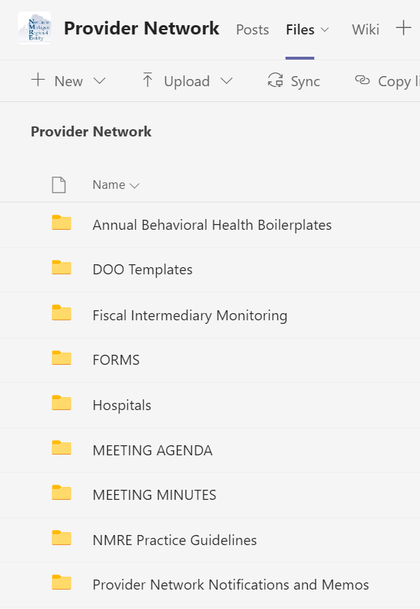
The folder has 3 subfolders: Contact List, Contracts and Correspondence, and Rate Chart(s). The contracts for each hospital are in the Contracts and Correspondence folder.
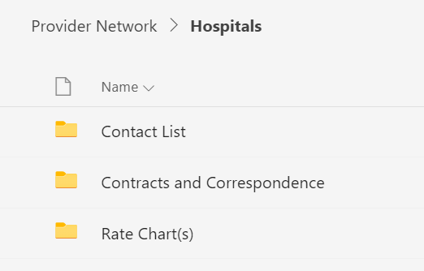
In the Contracts and Correspondence folder, select the applicable Fiscal Year.
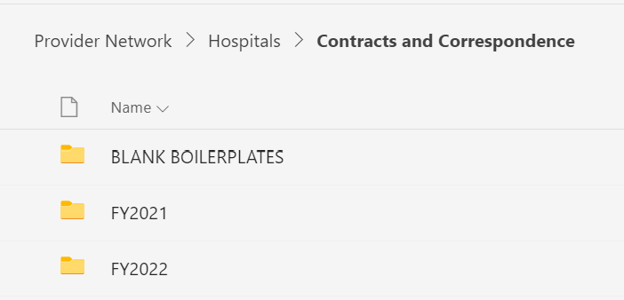
In the Fiscal Year folders, there are subfolders for each specific hospital. Again, they may have different clauses negotiated, such as timely filing or idemnification, so the specific boilerplate and applicable term extension for each specific provider is in the subfolders in this section
Rate Location
In the Provider Network TEAMS files, navigate back to the main Hospital folder.
In the “Rate Chart(s) folder, historic rate charts are stored. The current rate chart begins with “CURRENT”
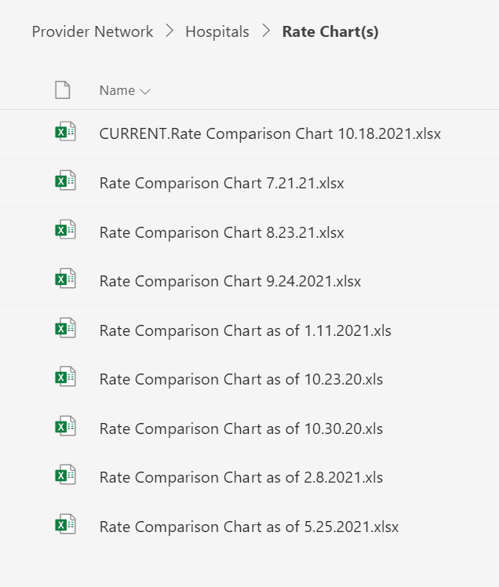
By opening the CURRENT rate chart, the viewer is able to see the current negotiated rate for each hospital, by service (partial hospitalization, per diem adult vs adolescent, etc.).
*Rates are prior approved by the regional Operations Ccommittee comprised of the CMHSP CEOs/Executive Directors.
Contact Info Location
In the Provider Network TEAMS files, navigate back to the main Hospital folder.
Current contact info is stored in the Contact List folder. Historic contacts are also available. The file that displays “CURRENT” is a listing of the current contacts, contract signatories, and other contact information for each inpatient hospital.

Common CMH Contracting Questions

- Signature page request has dual signatures on provider end – HOSPITAL X and HOSPTIAL X Physician partners. Hey Chip... I reread the principle agent discussion; as independent contractor, as long as both agent signatories have CMH’s interest as priority, and neither has authority over the other to sign but both are liable, this is allowable correct? Our parties block states “…McLaren Bay, whose principle administrative offices are located at McLaren Physician Partners.” Perhaps a good subject for further group discussion
  - Two parties signing..um….no, not typically you are correct..Who owns whom? The owner signs….This situation needs more explanation as it is not entirely out of the question but…
The rest of the story, The parent company wanted the sub-contractor to be fully aware of the terms of the agreement and thus a co-signatory. As long as this is understood it is acceptable.

- XIII Authorization of Services C. I did accept a change from “Payor’s CEO or the CEO’s designated representative” to just “payor” would this be okay?
  - This full explains who can authorize. For example, if it is left Payor and as a CEO one of my agents agrees to an authorization without the specific authority to do so and then later I find out about it, I as the CEO can blame whomever told them they had no authority etc….and reverse the decision on them, or be stuck with a payment that would come out of local funds. They in turn would most likely appeal the disapproval and a mess would ensue…. I think for both their and our protection is should remain, if it is a deal breaker they should be forewarned in advanced that we may deny a future payment if an unauthorized CMH agent approves x, y, or z….

- A contractor wanted to delete the return of property clause in XXVII, H. Can we?
  - No, we’re going need our stuff back…PIHP contract page 96 11.0 SUBCONTRACTOR INFORMATION TO BE RETAINED AT THE PIHP
  - 4. a. Any contractor equipment purchases supported in whole or in part through this agreement must be listed in the supporting Equipment Inventory Schedule. Equipment means tangible, non-expendable, personal property having useful life of more than one (1) year and an acquisition cost of $5,000 or more per unit. Title to items having a unit acquisition cost of less than $5,000 shall vest with the Contractor upon acquisition. The Department reserves the right to retain or transfer the title to all items of equipment having a unit acquisition cost of $5,000 or more, to the extent that the Department’s proportionate interest in such equipment supports such retention or transfer of title.

- If we have a provider who would cross over templates – can we use one template and put all codes in? Would we need to add things from one template to another or just in the exhibits to cover the second service code? As an example – we have a provider for Crisis Res and Respite…

  - Yes, you would go to the more restrictive of the two. So, in the example given, you would use Crisis Residential….

- You stated that a contract extension could be agreed to by the two parties and a letter or Amendment signed. But, without such an Agreement extension, that based on Federal Code, no payment can be made to the provider even if they continue to provide services. We have been advised in the past by an attorney that payment cannot be withheld for services that are delivered without a contract and CMH is aware of the services being delivered. This is the legal theory of “Unjust Enrichment”. Payment cannot be withheld for actual services delivered when the payor is aware of these services.
  - There is no unjust enrichment as you are only holding the money until the Provider comes into compliance with federal and state regulations/rules. To pay them potentially puts you out of compliance with many aspects of the PIHP/MDHHS and the PIHP/CMHSP contracts leading to the potential of having to repay the PIHP/state and in turn the providers will have to pay you back....or maybe not if you don't have a contract.
  - Citations are found in the MDHHS/PIHP Contract (Attachment P37.0.1 and Attachment 39.0.1) and is 2 CFR, Part 200, Subpart E Cost Principles, 200.403(g) which state, “The following items should be considered in determining allowable costs:
  - Federal cost principles (2 CFR 200.402) require that for costs to be allowable they must meet the following general criteria:

- Be necessary and reasonable for the performance of the Federal award and be allocable thereto under the principles.
- Conform to any limitations or exclusions set forth in the principles or in the Federal award as to types or amount of cost items.
- Be consistent with policies and procedures that apply uniformly to both federally-financed and other activities of the non-Federal entity.
- Be accorded consistent treatment.
- Be determined in accordance with generally accepted accounting principles.
- Not be included as a cost or used to meet cost sharing or matching requirements of any other federally-financed program in either the current or a prior period.
- Be adequately documented.

  - Reimbursements to subcontractors (including PIHP payments to CMHSPs for Medicaid services) must be supported by a valid subcontract and adequate, appropriate supporting documentation on costs and services (2 CFR Part 200, Subpart E – Cost Principles, 200.403 (g)).

- A SERIES OF TYPE B RESIDENTIAL QUESTIONS

- Would this boilerplate also apply for Licensed Children’s Foster Care or Child Caring Institutions?
NO because you cannot pay for room and board at a CCI. I have a LCFC contract template that is very similar to this. But, this contract is seldom used.

B) I have done word searches cannot seem to find statements covering the topics below in 1. – 13. Would you be able to reference the corresponding paragraphs in this contract? Are these covered by default in some other area? If not in the main pages of the contract, please indicate if these should be added to the exhibits?
1. Does it say anywhere that the contractor is responsible to know and comply with the payor’s Provider Manual, policies and procedures?
Yes, a few references:
XVIII. Applicable Law and Venue, Compliance with the Law, section D: “When providing supports/services under this Agreement, the Provider, its officers, employees, servants, and agents shall abide by all applicable provisions and requirements for supports/services as set forth in the Mental Health Code, the MDHHS Rules, Medicaid and Medicare regulations, the MDHHS/CMHSP Master Contract for General Funds, MDHHS/PIHP Master Contract for Medicaid funds, and in policies, procedures, standards and guidelines established by the Payor therefor.”

Also in XI. Provider Services, Supports, Responsibilities, H: for behavioral treatment responsibility, XX. Health and Safety of Consumers, B: for recipient rights policies of payor, XXIII.: For disclosure of ownership.
If adding “Provider Manual” is a sticking point, Exhibits, C, E, F, and G are probably good ones to reference it depending on manual’s contents
2. Does it say anywhere that the contractor must be in compliance with payor’s clinical protocols
In XVIII and XI, below:
XVIII. APPLICABLE LAW AND VENUE; COMPLIANCE WITH THE LAW.
D. When providing supports/services under this Agreement, the Provider, its officers, employees, servants, and agents shall abide by all applicable provisions and requirements for supports/services as set forth in the Mental Health Code, the MDHHS Rules, Medicaid and Medicare regulations, the MDHHS/CMHSP Master Contract for General Funds, MDHHS/PIHP Master Contract for Medicaid funds, and in policies, procedures, standards and guidelines established by the Payor therefor.
XI. Provider Supports, Services, and Responsibilities covers this as well; specifically, section B, which allows your agency to put whatever adjustments necessary into Exhibit C, Scope of Services
3. Does it say anywhere that “the sum of first party, third party and CMH payments shall not exceed the lesser of the third-party payer’s maximum allowed amount or the contractor’s contracted rate.
Yes, XIV. Billing of and Valid Payments for Services has financial status and eligibility requirements, as well as in section D, E, F, G.
D. Coordination of Benefits The Provider acknowledges that the Payor shall be the payer of last resort for Payor-authorized supports/services to Payor-authorized Consumers under this Agreement subject to the terms and conditions herein. The payments from the Payor to the Provider under this Agreement are intended only to cover the allowable costs of the specialty supports/services net of and not otherwise covered by payments provided by other funding, entitlements or benefits and by liable third parties, as applicable, for which each recipient of services hereunder may be eligible.”
E. Third-Party Liability Requirements. The Payor is required to identify and seek recovery from all liable third parties, consistent with the requirements of the Mental Health Code, the MDHHS/CMHSP Master Contract for General Funds, and with the MDHHS/PIHP Master Contract for Medicaid Funds. The Payor shall be responsible under this Agreement for seeking support/service reimbursements, if applicable, from third-party liability claims for Consumers hereunder, pursuant to federal and State requirements.
The Provider shall not seek or collect any support/service fee payments directly from consumers, legal guardians, parents or relatives, etc. or any reimbursement fee payments from Medicare, and/or private insurers, the State of Michigan, health maintenance organizations, or other managed care entities acting on behalf of private insurers, etc., for Provider’s supports/services rendered hereunder, unless authorized to do so, in writing, by the Payor.
F. Payment in Full. Payments from the Payor for valid claims for Payor-authorized supports and services rendered by the Provider to the Payor’s Consumers under this Agreement shall constitute payment in full. The Provider shall be solely responsible for its payment obligations and payments to its subcontractors, if any, for performing supports and services required of the Provider under this Agreement. Payments from the Provider to its subcontractors for performing supports and services required of the Provider hereunder shall be made on a timely basis and on a valid claim basis.
Provider and/or its subcontractors, if any, shall not seek or collect any support/service fee payments directly from consumers, legal guardians, parents or relatives, etc., unless specifically authorized by the Payor, in writing, to do so. It is expressly understood and agreed by the Provider that:
- The Provider and/or its subcontractors shall not require any co-payments, recipient pay amounts, or other cost sharing arrangements for the Provider’s supports/services required hereunder and/or for supports/services of a subcontractor, unless specifically authorized by the Payor, the State or federal regulations and/or policies thereof.
- The Provider and/or its subcontractors shall not bill individuals for any difference between a supports/services charge of the Provider or of a subcontractor and the Payor’s payment for the Provider’s supports/services required hereunder.
- The Provider and/or its subcontractors shall not seek nor accept additional supplemental payments from the individual, his/her family, or representative, for the Provider’s supports/services required hereunder and/or for the supports/services of a subcontractor.
G. Refunding of Payments. Provider shall not bill the Payor for supports/services rendered hereunder in any instances in which the Provider received monies directly for them from another funding source or from another party that provides for, reimburses, offsets, or otherwise covers payment retroactively, currently, or subsequently for such supports/services. At any time it is determined, after supports/services claims reimbursement to the Provider has been made by the Payor, that the Provider received monies directly for the supports/services from another funding source or from another party that provides for, reimburses, offsets, or otherwise covers payment retroactively, currently, or subsequently for such supports/services, the Provider shall refund to the Payor an amount equal to the sums reimbursed by third party payors and/or paid by any other source. Provider shall notify Payor immediately of any receipt of such monies for such purposes hereunder.
4. Does it say that the Contractor must be in compliance with Advanced Directives 42CFR 422.128 and 42 CFR 438.6.
XXVI. Section C. “Payor and Provider shall comply with MDHHS and/or PIHP information requirements and standards, including those for Advance Directives”; that puts you in compliance with 42 CFR 422.128.
Much like the HIPAA/BAA discussion we had recently, Advanced Directives was a hot topic shiny and new for MDHHS and was in the body template. It has become just one of those many things we have to keep track of. I can be part of the Exhibits you pick. At CWN it is in the training section of our contracts/exhibits.
“XVIII. APPLICABLE LAW AND VENUE; COMPLIANCE WITH THE LAW.
D. When providing supports/services under this Agreement, the Provider, its officers, employees, servants, and agents shall abide by all applicable provisions and requirements for supports/services as set forth in the Mental Health Code, the MDHHS Rules, Medicaid and Medicare regulations, the MDHHS/CMHSP Master Contract for General Funds, MDHHS/PIHP Master Contract for Medicaid funds, and in policies, procedures, standards and guidelines established by the Payor therefor.”
If that’s not enough you can add more to Exhibit F as needed.
5. Does it say that the Contractor has a requirement to notify us immediately if circumstances interfere with their performance of the contract in any way?
Yes. XII. Section D regarding staffing projection issues and changes, XX. Section A. regarding changes in the health and safety of consumers, XX. Section E. regarding law enforcement and regulatory agency inquiries and findings, XXVI. Section I regarding housing changes in compliance and facility conditions, XXVI. J regarding fire safety system hazards, XXVI. Section. L regarding traffic violations, XXX. Regarding non-compliance regarding subcontracts and assignment; as well as XV. With regard to Quality Assessment and Outcome studies, listed below:
XII. STAFFING AND TRAINING REQUIREMENTS.
D. The Provider shall notify the Payor’s CEO or the CEO’s designated representative immediately whenever:
(1.) the Provider's staffing and staff/recipient ratio become contrary to those used for projections in Payor’s determination of the reimbursement methodology/rate(s) for supports/services, as set forth in "Exhibit C";
(2.) Provider's staffing of supports/services required under this Agreement has not been or cannot be provided; or,
(3.) the need for supports/services to a Consumer is otherwise less than or greater than Provider's staffing levels agreed upon hereunder by the parties.
XX. HEALTH AND SAFETY OF CONSUMERS; RECIPIENT RIGHTS AND CONSUMER GRIEVANCE PROCEDURES.
A. The Provider shall monitor the health, safety and welfare of each Consumer while he or she is under its service supervision pursuant to this Agreement. The Provider shall provide immediate comfort and protection to and secure immediate medical treatment for a Consumer if he/she suffers physical injury. The Provider shall notify the Payor’s CEO immediately of any event or information that raises questions regarding the health and safety of any Consumer being served hereunder.
C. The Provider shall report any sentinel event involving any Consumer hereunder immediately to the Payor’s CEO or said CEO’s designated representative and, as applicable, to the appropriate licensing Department or Agency of the State of Michigan, law enforcement agencies, and other public agencies, as required by law. The Provider agrees to allow individuals who properly identify themselves as representatives of Michigan Protection and Advocacy Services access during reasonable hours to applicable premises, recipient(s) of services, and service records in compliance with Section 748(7) and Section 931 of the Mental Health Code. The Provider shall provide the Payor’s Recipient Rights Officer with copies of all investigative reports and summary reports involving the Payor’s Consumers.
E. Provider shall inform, in writing, the Payor’s CEO of any notice to, inquiry from, or investigation by any federal, State, or local human services, fiscal, regulatory, investigatory, prosecutory, judicial, or law enforcement agency or protection and/or advocacy organization regarding the rights, safety, or care of a Consumer served under this Agreement. Provider also shall inform, in writing, Payor’s CEO immediately of any subsequent findings, recommendations, and results of such notices, inquiries, or investigations.
XXVII. MONITORING THE AGREEMENT; RESOLUTION OF CONTRACT ISSUES AND SERVICE DISPUTES.
A. The performance of the terms of this Agreement shall be monitored on an ongoing basis by the designated representatives of the Payor and of the Provider. The Payor’s CEO shall appoint administrative and program liaisons to be available to communicate with the Provider’s liaisons.
B. Contract issues between the Payor and the Provider as to specific provisions of this Agreement and implementation thereof and/or service disputes hereunder shall be addressed by the designated representatives of said respective parties. Unresolved contract issues, as to specific provisions of this Agreement and implementation thereof, and/or service disputes hereunder shall be referred to the Payor’s CEO for a final determination. The Payor’s CEO shall furnish the Provider with written notice of any such final determination hereunder.
C. In situations requiring corrective action, the designated representative(s) of the Payor’s CEO and the Provider's designated representative(s) shall meet to enable the Payor’s staff to finalize a Payor-authorized plan of corrective action for a contractual service resolution. Such a corrective action plan must be approved by a designated representative of the Payor’s CEO, before being implemented. If the Provider objects to the Payor-authorized corrective action plan involving supports/services to be provided hereunder to the Consumer(s), the Provider may appeal any such determination to the Payor’s CEO within twenty-four (24) hours after notification of the corrective action plan. The parties hereto agree that implementation of any such Payor-authorized plan of corrective action must begin within twenty-four (24) hours after the Payor’s staff has notified the Provider of the plan of corrective action unless the Payor’s CEO specifies, in writing, a greater or lesser time period for implementation of said plan.
XV. QUALITY ASSESSMENT AND PERFORMANCE IMPROVEMENT; PERFORMANCE INDICATORS; CONSUMER ASSESSMENTS AND OUTCOMES MANAGEMENT STUDIES.
A. The Provider, pursuant to this Agreement, shall maintain a fully operational Quality Assessment and Performance Improvement Program (QAPIP) which meets the QAPIP requirements and standards of the Payor.
B. The Provider shall meet the performance indicators set forth in the attached document labeled "Exhibit G" (“PERFORMANCE INDICATORS AND OBJECTIVES”), which is incorporated by reference into this Agreement and made a part hereof.
C. The Provider agrees, pursuant to this Agreement, to cooperate fully in the Payor’s implementation of:
(1.) performance improvement projects;
(2.) quantitative and qualitative member assessments periodically, including consumer surveys, focus groups and other consumer feedback methodologies;
(3.) regular measurement, monitoring, and evaluation mechanisms as to services, utilization, quality, and performance;
(4.) systems for periodic and/or random compliance review or audit; and,
(5.) studies to regularly review outcomes for service recipients as a result of programs, treatment, and community services rendered to individuals in community settings.
XXVI. MISCELLANEOUS PROVISIONS.
I. Facility Conditions. The Provider shall notify the Payor immediately, in writing, of any determination that the Facility which houses Consumers under this Agreement:
(1) Is not in compliance with applicable housing, building construction, and zoning codes;
(2) Is in need of repairs in order to be consistent with applicable housing, building construction and zoning codes; or,
(3) Is otherwise unsuitable.
J. Fire Safety System. The Provider shall ensure that the fire safety system, which includes a primary and back-up smoke detection system, at the Facility is operational and meets the licensing/certification requirements of the MDHHS Rules at all times and is tested periodically and inspected annually. The Provider shall maintain records of such inspections at the Facility. The Provider shall notify the Payor immediately, in writing, of any determination that the fire safety system is defective and shall take action to repair the system upon discovery of any defect. The Provider also shall conduct and document fire drills which meet the licensing/certification requirements of the MDHHS Rules.
L. Transporting Consumers. The Provider shall ensure that all vehicles used for transporting the Consumers under this Agreement are at all times in safe operating condition. The Provider shall ensure that a safety inspection of each vehicle is completed by a licensed mechanic not less than once every twelve (12) months in order to assure the Payor of the vehicles' safety for transporting the Consumers.
The Provider shall permit only responsible staff with an appropriate valid driver's license, as required by State law, to operate motor vehicles while transporting the Consumer(s) hereunder. The Provider agrees to immediately notify the Payor’s CEO or the CEO’s designated representative of any traffic violations, accidents, or hazardous incidents involving the Provider's vehicles during the transporting of Consumers served under this Agreement.
While transportation to Early Periodic Screening, Diagnosis and Treatment Program (EPSDT) is not a covered service under this Agreement, the Provider shall assist the Consumer(s) hereunder in obtaining necessary transportation to EPSDT services either through the State of Michigan’s Department of Health and Human Services or through the Consumer’s Medicaid medical health plan.

6. Does it say anywhere as to the credentialing requirements and what that might include?
In VI. LICENSES, ACCREDITATIONS, AND CERTIFICATIONS; AND, CREDENTIALING AND PRIVILEGING REQUIREMENTS AND QUALIFICATIONS, section A and B, and XXX. Assignment contains provisions for any subcontracted portions. Exhibit D, while not credentialing related, contains training requirements.
VI. LICENSES, ACCREDITATIONS, AND CERTIFICATIONS; AND, CREDENTIALING AND PRIVILEGING REQUIREMENTS AND QUALIFICATIONS.
A. The Provider shall obtain and maintain during the term of this Agreement all licenses, certifications, registrations, National Provider Identifier pursuant to Section 5005 and Section 12006 of the 21st Century Cures Act, Home and Community Based Services regulations (HCBS), accreditations, authorizations, and approvals required by federal, State and local laws, ordinances, rules and regulations for the Provider to operate an adult foster care facility and provide Medicaid and/or non-Medicaid programs and supports/services within a specialized residential setting in the State of Michigan.
Prior to commencing supports/services under this Agreement, the Provider, as applicable, shall furnish the Payor with notice of primary verification that its staff have obtained and maintain all approvals, accreditations, certifications and licenses required by federal, State and local laws, ordinances, rules and regulations to practice their vocation in the State of Michigan and to perform Medicaid and/or non-Medicaid supports/services hereunder.
If any such license, certification, accreditation, or authorization is ever suspended, restricted, revoked, or expires and is not renewed, the Provider shall immediately notify the Payor, in writing.
B. The Provider, as a member of the Payor’s service provider network, shall cooperate with the Payor on an ongoing basis and, as applicable, shall ensure that its professional staff, if any, meet the Payor’s credentialing and privileging requirements, including annual reprivileging and competency standards, and/or that its nonprofessional staff meet the Payor’s requirements for qualifications and competency standards necessary to perform the supports/services required under this Agreement.
XXX. ASSIGNMENT.
C. If the Provider, with the Payor’s prior consent, subcontracts any supports/services required of the Provider under this Agreement, any such subcontract shall:
Any subcontractor shall ensure, as applicable, that its professional staff, if any, meet the Payor’s credentialing and privileging requirements, including annual reprivileging and competency standards and/or that its nonprofessional staff meet the Payor’s requirements for qualifications and competency standards, necessary to perform the subcontracted supports/services.
7. Does it say anywhere that payor can require provider submit to a financial audit, even if normally not required to have an annual audit as their reimbursements may be under $500,000
V. PROOF OF PROVIDER’S BUSINESS STATUS; REQUIREMENTS OF PROVIDER SOLVENCY; AND, CERTIFICATION REGARDING DEBARMENT OR SUSPENSION.
A. The Provider shall furnish the Payor with notice of proof of the Provider’s authority to conduct business in the State of Michigan and in what business capacity, prior to commencing services under this Agreement, and with notice of any related organization of the Provider per alliance, affiliation, joint venture, parent/subsidiary or other business relationship that the Provider is a party to during the term hereunder.
B. Pursuant to 42 CFR 455.104-106 The Provider shall furnish the Payor with notice of proof of financial solvency, prior to commencing supports/services hereunder, and with immediate notice of any change in financial position material to the Provider’s solvency and to its continuing in operation as a going concern, at any time during the term of this Agreement.
C. This Agreement shall terminate effective immediately upon receipt of notice and/or discovery by the Payor of any failure of the Provider to meet the requirements hereunder of solvency and of continuing as a going business concern or if the Provider generally fails to pay its debts as they become due.
XVI. REPORTING REQUIREMENTS; ACCOUNTING PROCEDURES AND INTERNAL FINANCIAL CONTROLS
A. The Provider shall report financial, program, service and consumer data and additional statistical and other management information in the manner and at the times prescribed by the Payor’s CEO.
B. The Provider's accounting procedures and internal financial controls shall conform to generally accepted accounting principles in order that the costs allowed by this Agreement can be readily ascertained and expenditures verified therefrom. The Provider shall maintain accounts and source records in which any and all revenues received pursuant to this Agreement are ascertainable and verifiable and include date of receipt and sources of funds. Per the Provider’s billings of claims to the Payor, costs allowed by this Agreement also must be readily ascertainable and verifiable. The Provider understands and acknowledges that its accounting and financial reporting under this Agreement must be in compliance with MDHHS accounting and reporting requirements. Thereto, accrual accounting and reporting shall be the methodology implemented by the Provider for the purposes of this Agreement.
F. For any fiscal year involving the contractual period covered under this Agreement, the Provider shall have a certified public auditing firm perform an annual independent audit of it, in substantial conformance with the American Institute of Certified Public Accountants Guide, to assess:
(1.) compliance with the appropriate standard accounting practices and procedures required of the Provider;
(2.) the Provider’s operating results for the annual period, its financial position at the end of said period, and, thereto, its status as to solvency and to continuing in operation as a going concern;
(3.) compliance with the terms of this Agreement, as to the accuracy of the revenues, expenditures, allocated costs, financial position, and solvency/going concern status claimed by the Provider and reported to the Payor hereunder; and,
(4.) compliance with applicable federal and State laws governing its operations. The Provider shall submit a complete and accurate copy of such independent audit for each fiscal year by no later than THREE (3) months after the close of any such fiscal year.
XVII. PROGRAM AND FINANCIAL BOOKS, DOCUMENTS, AND RECORDS; AUDITS; REVIEWS; AND, PROGRAM/SERVICE EVALUATIONS.
A. Parties to the MDHHS/PIHP Master Contract for Medicaid funds and to the MDHHS/CMHSP Master Contract for General Funds for purposes thereof, Payor for purposes hereof, the federal government, State of Michigan, or their designated representatives shall be allowed to inspect, review, copy, and/or audit all financial records and license, accreditation, certification and program reports of the Provider and to review all clinical records of the Provider pertaining to performance of this Agreement, to the full extent permitted by applicable federal and State law. Clinical and financial records and supporting documentation of the Provider must be retained and be available for audit, review or evaluation purposes for a minimum of TEN (10) years after the termination of this Agreement and in accordance with the Michigan Department of Attorney General State Operations Division General Schedule #20 Community Mental Health Programs Dated March 2, 2007.

8. Does it say anywhere that “The contract and its referenced exhibits are intended by the parties to constitute the entire and integrated understanding between them. The Contract may be modified only by written amendment. No oral amendments may be made to this contract.”
XXXII.COMPLETENESS OF THE AGREEMENT. This Agreement, the attached Exhibits, and the additional and supplementary documents incorporated herein by specific reference contain all the terms and conditions agreed upon by the Payor and the Provider and no other agreements, oral or otherwise, regarding the subject matter of this Agreement or any part thereof shall have any validity or bind either the Payor or the Provider.”
XXIX. AMENDMENT. Modifications, amendments, or waivers of any provision of this Agreement may be made only by the written mutual consent of the parties hereto.
9. This is a big one! Does it say anywhere that ” Nothing shall be construed as a waiver of any governmental immunity the Payor or Payor’s employees have as provided by statute or modified by court decisions
Remember we are buying the service and we are covered under the Mental Health Code as referenced at the very beginning:
“WHEREAS, the Payor is a community mental health ________ (CMH_) established by the Board(s) of Commissioners of the Counties of ____ and ____ pursuant to Act 258 of the Public Acts of 1974, as amended (hereinafter referred to as the "Mental Health Code");”, “II. CONTRACT AUTHORITY. This Agreement is entered into pursuant to the authority granted to the Payor under the Mental Health Code. This Agreement is in accordance with the rules, regulations, and standards (hereinafter referred to as the "MDHHS Rules") of the MDHHS adopted and promulgated in accordance with the Mental Health Code.”, and “The Mental Health Code, the MDHHS Rules, the MDHHS/CMHSP Master Contract for General Funds, and the MDHHS/PIHP Master Contract for Medicaid Funds and applicable State and federal laws shall govern the expenditure of funds and provisions of services hereunder and govern in any area not specifically covered by this Agreement.”
---The wavier of any governmental immunity is a consideration/concern when we enter into other contractual arrangements such as vendors buying our services or the use of a contract that does not use the aforementioned language.
10. Does it say anywhere that the Insurance carriers who cancel contractor’s insurance coverage is required to notify Payor? Does it say that Payor shall be listed on general liability coverage as ‘additional insured. These requirements exist in our standard master contract but not in this boilerplate.
XXV. LIABILITY INSURANCE.
A(6). The Payor, its elected and appointed officers, employees, servants and agents shall be named as Additional Insureds on the Provider’s insurance coverage required in Items 4 and 5 above. It is expressly understood and agreed that the Provider's liability coverage required in Items 4 and 5 above shall be primary to the Additional Insureds and not contributing with any other insurance or similar protection available to the Additional Insureds, whether said other available coverage be primary, contributing or excess.
B. The Provider shall submit certification of its insurance coverage to the Payor prior to the execution of this Agreement. The certificates of insurance for the Provider shall contain a provision stating that coverages afforded under the policies will not be changed or canceled until at least thirty (30) days prior written notice has been given to the Payor. The Provider shall provide the Payor with written notification at least thirty (30) days prior to any reduction or termination of the insurance coverage required herein.
11. I am looking for a broad statement that defines the reasons why a contract may be terminated immediately. Where might that be?
It would not be reasonable to have a single broad statement that lists all of the reasons; the various reasons are therefore covered in respective sections in the contract; in VIII. Termination of Agreement, Sections A, B, C, D. Example, “D. Any breach of this Section shall be regarded as a material breach of this Agreement and may be a cause for termination thereof by the Payor.”
12. Does it say that Contractor is responsible for any damages or penalties incurred by the Payor, due to breaches of the contract by the Contractor, including financial penalties for late filing of reimbursement requests, or other financial reporting?
XXIV. INDEMNIFICATION AND HOLD HARMLESS.
A. The Provider shall, at its own expense, protect, defend, indemnify, and hold harmless the Payor and its elected and appointed officers, employees, servants and agents from all claims, damages, costs, and expenses, arising from personal and/or bodily injuries or property damage that any of them may incur as a result of any acts, omissions, or negligence by the Provider, and/or its officers, employees, servants, or agents that may arise out of this Agreement.
B. The Provider’s indemnification and hold harmless responsibilities under this section shall include the sum of claims, damages, costs, lawsuits and expenses which are in excess of the sum reimbursed to the Payor and its elected and appointed officers, employees, servants and agents by the insurance coverage obtained and/or maintained by the Provider pursuant to the requirements of this Agreement.
XIV. BILLING OF AND PAYMENTS FOR VALID SUPPORTS/SERVICES REIMBURSEMENT CLAIMS.
G. Refunding of Payments. Provider shall not bill the Payor for supports/services rendered hereunder in any instances in which the Provider received monies directly for them from another funding source or from another party that provides for, reimburses, offsets, or otherwise covers payment retroactively, currently, or subsequently for such supports/services. At any time it is determined, after supports/services claims reimbursement to the Provider has been made by the Payor, that the Provider received monies directly for the supports/services from another funding source or from another party that provides for, reimburses, offsets, or otherwise covers payment retroactively, currently, or subsequently for such supports/services, the Provider shall refund to the Payor an amount equal to the sums reimbursed by third party payors and/or paid by any other source. Provider shall notify Payor immediately of any receipt of such monies for such purposes hereunder.
H. Unallowable Supports/Services/Cost Claims and Financial Paybacks. Should the Provider fail to fulfill its obligations as required under this Agreement, thereby resulting in unallowable Medicaid or non-Medicaid program supports/services and/or cost claims, it shall not be reimbursed by the Payor hereunder for any such supports/services and/or cost claims; thereto, the Provider shall repay to the Payor as financial paybacks of any claims payments made by the Payor to the Provider for such unallowable supports/services and/or cost claims. This requirement shall survive the termination of this Agreement and such repayment shall be made by the Provider to the Payor within SIXTY (60) days of Payor’s final disposition notification to the Provider that financial payback by the Provider is required.
I. Disallowed Expenditures and Financial Repayments. In the event that the MDHHS, PIHP, the Payor, the State of Michigan, or the federal government ever determines in any final revenue and expenditure reconciliation and/or any final finance or service audit that the Provider has been paid inappropriately per the Payor’s expenditures of federal, State, and/or local funds pursuant to this Agreement for Medicaid or non-Medicaid program supports/services claims and/or cost claims which are later disallowed, the Provider shall fully repay the Payor for such disallowed payments within SIXTY (60) days of the Payor’s final disposition notification of the disallowances, unless the Payor authorizes, in writing, additional time for repayment.
13. Where in the master pages does it list all the Exhibits by title, and that they are considered part of the contract?
XXXII.COMPLETENESS OF THE AGREEMENT. This Agreement, the attached Exhibits, and the additional and supplementary documents incorporated herein by specific reference contain all the terms and conditions agreed upon by the Payor and the Provider and no other agreements, oral or otherwise, regarding the subject matter of this Agreement or any part thereof shall have any validity or bind either the Payor or the Provider.
Specific locations:
Exhibit A referenced in recitals section I “definitions”
Exhibit B referenced Section X
Exhibit C referenced Section XI, Part B and XII. Part A and C
Exhibit D in Section XII. Part F
Exhibit E, VIII, Part A
Exhibit F Section XIV. Part A
Exhibit G, XV. Part B
Exhibit H, Section XX. Part D
Exhibit I, Section XXIII
C. New Boilerplate Limits of insurance coverage are different than ours. Ours are higher coverage requirements. How to handle?
You can use yours. There’s no current risk management guidance to provide other than as we’ve discussed, the insurance amount determination is largely an “artform”. Insurance coverage is a very much negotiated issue.
D. Our contracts don’t specifically state Compliance with MDHHS/CMHSP Master Contract for General and Medicaid Funds as shown on page 3, Section IV. How can this contract hold the contractor responsible for compliance with another contract, when the providers don’t have a copy of it?
This section is stating that the PIHP/MDHHS contract and CMH General Funds contract take precedence if a conflict exists, and that the entire Type B contract is subject to terms in those 2 contracts. Those contracts are you. That language ties the funds, federal and state laws, and provision of care at the provider office together from the top to the bottom. As far as providing copies to providers; it may be provided on any platform you choose, email, cd, paper, etc. They are online too.
E. This contract has no automatic continuation clause. This is something we feel strongly should be in the contract for the basic reason that we would not be able to pay our providers for services performed past the term date according if we didn’t have this clause. We also cannot shortchange our provider by not paying them monthly as it would be detrimental to their cash flow. Additionally, our clients have to come first so despite frequently not being an approved budget till six months into the current financial year, we must continue client services. If the term has no automatic, month-to-month renewal pending issuances of an updated contract (which in some instances is backdated), then we are unable to put our clients first. We need to have an automatic, month-to-month continuation statement in the term, such as “ This contract is inclusive, and shall continue on a month-to-month basis thereafter upon the terms and conditions set forth herein and at the fee and service levels authorized in the Exhibits, until amended accordingly or until a successor contract is executed by and between the parties.”
Best solution is to send an annual contract with updates. Failing that, amendments would be my second preference as they could include other annual regulatory updates. Final answer… for now, I am not going to say one way or another that you can or can’t have month to month clause...but be advised that if there are changes in the CMH General Funds contract or your CMH/PIHP contract, or the PIHP’s Master contract, that date to October 1st, and your month-to-month runs past that, the changes may constitute a conflict where the prevailing terms will not exist in your agreement, as in the answer to question D above, and the CMH may be responsible for any non-compliance as a result. Bottom line, “I don’t like jail or large fines from the state/feds but that’s up to you.”

VII. How does a contractor know or how do we know when we must provide for Limited English Proficiency (LEP) concerns (the 5% clause).
Guidance for LEP can be found on a document from the Department of Justice called:
Part X Department of Justice, Guidance to Federal Financial Assistance Recipients Regarding Title VI Prohibition Against Original Discrimination Affecting Limited English Proficient Persons; Notice

VIII. Use of multi-year contracts. Why not?
There are drawbacks of doing multi-year contracts given the frequency of (Medicaid regulations, MSA, 42 CFR, MDHHS bulletins, State and Federal Law, etc) changes and of course annual funding appropriations. Also, you must keep in mind the 5-year limit regarding multi-year and evergreens (FAR 16.505(c), 17.103, 17.204(e)). Five-year limits originated with Department of Defense’s 5-year planning horizon. Annual contracting is best practice; to manage this a CMH with many contracts and a heavy workload may best look at processes to determine whether all the information/attachments are required every year. You may want to look at separating credentialing from the annual contract as credentialing, while still required, is not needed annually. In addition, a CMH in this scenario can find a way to put the onus on Providers to upload required information into a centralized repository for example.
So when you do multi-year contracts your templates should consider the following. You can skip overseas (maybe?? Canada?). However, most contract templates do not consider price adjustments etc. as they are single year agreements tied to the State appropriations process.
Title 48 FAR page 438 Section 17.109 Multi-Year Contract Clauses:
17.109 Contract clauses.
(a) The contracting officer shall insert the clause at 52.217-2, Cancellation Under Multi-Year Contracts, in solicitations and contracts when a multi-year contract is contemplated.
(b) Economic price adjustment clauses. Economic price adjustment clauses are adaptable to multi-year contracting needs. When the period of production is likely to warrant a labor and material costs contingency in the contract price, the contracting officer should normally use an economic price adjustment clause (see 16.203). When contracting for services, the contracting officer—
(1) Shall add the clause at 52.222-43, Fair Labor Standards Act and Service Contract Labor Standards- Price Adjustment (Multiple Year and Option Contracts), when the contract includes the clause at 52.222-41, Service Contract Labor Standards;
(2) May modify the clause at 52.222-43 in overseas contracts when laws, regulations, or international agreements require contractors to pay higher wage rates; or
(3) May use an economic price adjustment clause authorized by 16.203, when potential fluctuations require coverage and are not included in cost contingencies provided for by the clause at 52.222-43.

52.217-2 Cancellation Under Multi-Year Contracts.
As prescribed in 17.109(a), insert the following clause:
CANCELLATION UNDER MULTI-YEAR CONTRACTS
(OCT 1997)
(a) “Cancellation,” as used in this clause, means that the Government is canceling its requirements for all supplies or services in program years subsequent to that in which notice of cancellation is provided. Cancellation shall occur by the date or within the time period specified in the Schedule, unless a later date is agreed to, if the Contracting Officer—
(1) Notifies the Contractor that funds are not available for contract performance for any subsequent program year; or
(2) Fails to notify the Contractor that funds are available for performance of the succeeding program year requirement.
(b) Except for cancellation under this clause or termination under the Default clause, any reduction by the Contracting Officer in the requirements of this contract shall be considered a termination under the Termination for Convenience of the Government clause.
(c) If cancellation under this clause occurs, the Contractor will be paid a cancellation charge not over the cancellation ceiling specified in the Schedule as applicable at the time of cancellation.
(d) The cancellation charge will cover only—
(1) Costs—
(i) Incurred by the Contractor and/or subcontractor;
(ii) Reasonably necessary for performance of the contract; and
(iii) That would have been equitably amortized
2) A reasonable profit or fee on the costs.
(e) The cancellation charge shall be computed and the claim made for it as if the claim were being made under the Termination for Convenience of the Government clause of this contract. The Contractor shall submit the claim promptly but no later than 1 year from the date—
(1) Of notification of the nonavailability of funds; or
(2) Specified in the Schedule by which notification of the availability of additional funds for the next succeeding program year is required to be issued, whichever is earlier, unless extensions in writing are granted by the Contracting Officer.

(f) The Contractor’s claim may include—
(1) Reasonable nonrecurring costs (see Subpart 15.4 of the Federal Acquisition Regulation) which are applicable to and normally would have been amortized in all supplies or services which are multi-year requirements;
(2) Allocable portions of the costs of facilities acquired or established for the conduct of the work, to the extent that it is impracticable for the Contractor to use the facilities in its commercial work, and if the costs are not charged to the contract through overhead or otherwise depreciated;
(3) Costs incurred for the assembly, training, and transportation to and from the job site of a specialized work force; and
(4) Costs not amortized solely because the cancellation had precluded anticipated benefits of Contractor or subcontractor learning.
(g) The claim shall not include—
(1) Labor, material, or other expenses incurred by the Contractor or subcontractors for performance of the canceled work;
(2) Any cost already paid to the Contractor;
(3) Anticipated profit or unearned fee on the canceled work; or
(4) For service contracts, the remaining useful commercial life of facilities. “Useful commercial life” means the commercial utility of the facilities rather than their physical life with due consideration given to such factors as location of facilities, their specialized nature, and obsolescence.
(h) This contract may include an Option clause with the period for exercising the option limited to the date in the contract for notification that funds are available for the next succeeding program year. If so, the Contractor agrees not to include in option quantities any costs of a startup or nonrecurring nature that have been fully set forth in the contract. The Contractor further agrees that the option quantities will reflect only those recurring costs and a reasonable profit or fee necessary to furnish the additional option quantities.
(i) Quantities added to the original contract through the Option clause of this contract shall be included in the quantity canceled for the purpose of computing allowable cancellation charges.
(End of clause)
16.203 Fixed-price contracts with economic price adjustment.
16.203-1 Description.
(a) A fixed-price contract with economic price adjustment provides for upward and downward revision of the stated contract price upon the occurrence of specified contingencies. Economic price adjustments are of three general types:
(1) Adjustments based on established prices. These price adjustments are based on increases or decreases from an agreed-upon level in published or otherwise established prices of specific items or the contract end items.
(2) Adjustments based on actual costs of labor or material. These price adjustments are based on increases or decreases in specified costs of labor or material that the contractor actually experiences during contract performance.
(3) Adjustments based on cost indexes of labor or material. These price adjustments are based on increases or decreases in labor or material cost standards or indexes that are specifically identified in the contract.
(b) The contracting officer may use a fixed-price contract with economic price adjustment in conjunction with an award-fee incentive (see 16.404) and performance or delivery incentives (see 16.402-2 and 16.402-3) when the award fee or incentive is based solely on factors other than cost. The contract type remains fixed-price with economic price adjustment when used with these incentives.
IX. Community Living Supports/Respite issue. What notice does a CLS provider have to give to terminate services to a specific consumer? Our practice has been a 30 day notice. The issue with the clinical team is when a consumer has gone through every CLS provider on the Panel. The case managers need the time to find a new provider who is willing to provide CLS services and not have an interruption in services. Any interruption in services becomes a Recipient Rights issue. So, is a 30 notice from the provider reasonable?
CLS/Respite it is negotiated, and 30 days has precedence. So yes 30 should be enough. If a very difficult consumers 60 would also be acceptable…it can be negotiated.

X. Administrative Services contract Questions

When should MOU, BAA, and PO or Administrative service contracts be used?

Generally, MOUs are used with other county agencies (judiciary branch, sheriffs, county governments, ISDs). The MOU outlines the functions of both parties. In the case of CMHs, MOUs may be used for jail diversion for court systems, sheriffs, police, etc. When the amounts of these agreements involve exchange of money, especially in amounts exceeding $5,000, it’s preferable to use an Administrative Services contract (45 CFR 74.2 & 34; FAR 52.245-1-unit acquisition costs)

BAAs are typically between other healthcare providers; there is no exchange of dollars, these are generally put in place to cover HIPAA. It is not typically necessary to use a BAA with every contractor, and this language does not need to be in every contract; it is advisable to use BAAs when confidential data is being exchanged or when auditors or cleaning personal have access to Medical Records.

Purchase Orders and Administrative Services contracts will vary by use regarding to how long the services last, or the frequency of the services. For a one-time service may be acceptable to use a Purchase Order, such as plumbing repair. Requests for additional funding (enhanced staffing, durable medical equipment, enhanced pharmacy, dental/vision, builders making home modifications, etc.) can also be issued via purchase orders, but a recommendation would be for the CMH to verify what is in policy and procedure and use a BAA is necessary. For longer term services, especially as the costs to the CMH pass $5,000, the CMH has to weigh the risks of not having a more formal agreement and administrative services contracts should be used (snowplowing, etc). A note on this would be that special care needs to be taken to demonstrate compliance in the procurement process (RFI, RFP, RFQ, etc). Documentation of the efforts to have the administrative services contract signed for audits is recommended, and collection of DOOs if the account exceeds $25,000 are required (42 CFR 455.105). Procurement processes are geared to guard against fraud, waste, and abuse.

XI. Professional Group

Should contracts contain requirements for ‘national accreditation’, such as for Professional Groups boilerplates?
Professional Group contract template has a requirement for national accreditation that reads “Provider has been presented to the Payor as being a nationally credentialed facility.” National credentialing here refers to licensing; the credentialing, etc.. this is particularly important now because of new rules required NPI registry and EVV.

XII. CLS/Respite

- Should the (full size, comprehensive) contract should be used for (respite) providers who only provide services 1 week per year (family member)?
The decision is up to CMH based on what risk it is willing to accept. While it may be overwhelming for respite providers (advanced reading level) to use a comprehensive contract, it would benefit CMHSP to have the contract in place out of precaution. In the end the contract protects the clients and ensures appropriate services and proper insurances, certifications, etc.

- Are minimum training requirements in CMH contracts typically required by the PIHP?
Typically, yes, but the CMHSPs can add more if they have additional requirements.

- Should CMHSPs pay respite providers for training time? Is Specialized Residential Services training done online or in a classroom setting?
No, respite providers do not need to be paid for training; most trainings can be done online (other than recipient rights, CPR/First Aid). For Specialized Residential, providers are responsible for training their staff; trainings can be made available via website as well. Associated costs should be in the providers rate structure.

- At what point should providers furnish documentation of authority to conduct business in the state of Michigan, regarding page 3, Section V(A-B) of the CLS/Respite contract:
“The Provider shall furnish the Payor with notice of proof of the Provider’s authority to conduct business in the State of Michigan and in what business capacity, prior to commencing services under this Agreement…”
“Pursuant to 42 CFR 455.104-106 the Provider shall furnish the payor with notice of proof of financial solvency, prior to commending services hereunder…”
As stated in the verbiage, prior to commencing services. For established providers it should already be on file. If it has not been obtained, contractors should exercise due diligence to try to obtain it.

- Some contract boilerplates used for a variety of services may not have license, accreditation, certification, or privileging requirements that pertain to respite providers. How can this situation be handled?
Simply adding a “where applicable” can suffice without changing the contract or eliminating clauses. For CLS and respite contracts, the wording needs to be in a way that addresses the additional risk due to unlicensed provider staff.

XII. Fiscal Intermediary

- How can a CMH assure that Fiscal Intermediaries properly go about training and credentialing of providers hired by self-determined members?
The CMH should be requesting items such as background checks, primary verification, insurance, etc., ahead of time, as well as keeping a copy of the FI’s background check policy. Not all background checks are necessarily done by FI staff but it’s good to have it on hand. Typically, trainings are completed by the CMH but there is room for reciprocity here. Rights officer must verify trainings were done properly; nuances to specific CMH policies (recipient rights) may be addressed via exhibits in contract.

- Can one-sided indemnity be changed?
This is an area of the Contract that may be changed to two-sided as needed. Or left mute/deleted entirely.

- How much insurance must a provider carry?
Many PIHPs do not require standardized amounts. While $1M per occurrence and $3M aggregate are the norm, they depend largely on the agency’s risk tolerance. A formulary from MMRMA was generally used; but no new risk management guidance has been issued in a very long time. The insurance amount determination is largely an “artform.” The more coverage you can get, the better from a risk standpoint; perhaps start from $2M/$5M and negotiating with Providers from there, though $2M/$5M would often not be required for “Mom and Pop” providers.

- How should a CMH handle establishing a contract and obtaining the required documentation in an emergent situation?
Usually those situations can be handled like a request for inpatient hospitalization: by using a single-case agreement and follow-up after the service is required for document verification and full contract execution.

- Is a certified public audit required for an FI contract if for only a couple individuals? Is there a dollar limit for audit requirement?
They’re handling another person’s money, so you have to handle that somehow. In the FI contract Section XVII(F) of the Contract Boilerplate, the contract authorizes the CMHSP (Payor) to review the records. This boilerplate does not specify a limit ($500K or $750K, etc) that requires a public audit. A CMH may add a limit under the Performance Section if it elects to and is stated in policy. If one CMHSP requires the audit and others do not, a shared provider may question the difference. Worthy of note- there is a dollar limit requirement that stems from the single audit requirement for federal funds, but that is unrelated to FI’s specifically.

XIII. Independent AFC Placements Type A/B

What is Type A vs Type B Residential?
- Type A Residential contract is used for a Provider-owned AFC with a 1:6 staffing ratio, which addresses any additional 1:1 staffing above what is required by licensing. In Type A the Payor will have to ensure that language exists in its contract referencing authority for placements, termination of agreement due to removal, etc.

- Type B is used for CMHSP owned or leased Homes; the CMHSP controls the beds, typically for 6 high need individuals and contracts for the Home staffing. In Type B, language exists that does not in Type A for possible review of provider revenue costs and expenditures due to possible vacancies at the home due to Payor placement decisions and/or net cost contracting.

XIV. What is the best way to add staffing ratios to calculate reimbursement in a contract?
The ratio is calculated in the exhibit section using the number of FTEs required, the number of clients being served, and the number of CLS hours required (from the Person-Centered Plan). This presents a situation which requires an amendment anytime a client is added to or removed from the services covered under the contract.

- How do I handle a provider that responds to my agency’s contract’s timely filing provision with an extension request, or with a recital of Medicaid’s 12 month timeline?
Medicaid providers will frequently respond to CMH or PIHP contracts with requests to extend timely filing requirements, reciting the Medicaid Manual (Section 12.3 Billing Requirements as of 7.10.20) 12 months from date of service provision. A CMH or PIHP does not necessarily have to grant this request as our agreements operate independently but also within the confines of State GF and State/PIHP Master contracts. Timelines in the PIHP and CMH State contracts are different, as CMH reports due to PIHPs versus PIHP reports due to State differ-- but will all fall into guidelines of final performance and financial reports to State due no later than 90 days following the State contract end date. So, how to handle?
Ultimately there are 3 general ways to handle this request. 1) Do not concede/do not go above the closeout provision with your State GF or PIHP master contract. You, as contract manager, will need to consult your GF and PIHP/MDHHS contracts to make yourself aware of closeout dates within each; basically do not change the language in any way. If you do budge, pay special attention to the final timeline of closeout requirements within the State GF and your PIHP contracts; this is likely going to be no more than 60 or 90 days. Explain this to the provider, prepare to stand firm, and see #2. #2) Don’t contract. This option becomes more feasible when the utilization volume is low, site reviews indicate the provider needs performance improvement, or when other factors make the provider difficult to work with or demonstrate poor quality of care. When the provider attempts to force your agency into a position to non-comply with the state, and the above conditions are met, it may be a good opportunity to forego the contract. #3) Concede your original filing…allowing for closeout. This is an absolute last resort and rarely advisable; providers will use the language in your contract and push that onto other agencies as well, could delay claims filing further across the BH system. Technically a Medicaid agency could attempt language allowing claims submitted 365 days from DOS “…but with claims submitted after December 31 may be denied with no appeal” and still meet its reporting requirements. Any language within the agreement referring to claims submitted in 12 months is not a recommended practice as it allows room for provider appeal and disputes, conflicts with closeout, and gambles with possible auditing red flags. Conceding timely filing requirements, in any capacity, should only be considered if the following 3 conditions are met: the provider is absolutely necessary to your agency based upon utilization volume or specialty services, the current timeline has been confirmed as the deal breaker by the provider, and language protecting your agency from closeout non-compliance exists absolutely.

