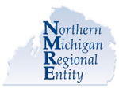
NMRE Annual Day of Education
For beneficiaries of NMRE Mental Health and Substance Use Disorder services
Take-i Time for Self Care


- Thursday, May 22, 2025, from 9 a.m. to 3 p.m.
- Treetops Resort, 3962 Wilkinson Rd., Gaylord, MI
-Offering multiple sessions to choose from for your specific interest
-Informational Tables from providers
-A light continental breakfast and lunch provided

To Register (limited spaces available!):
NMRE Day of Education Tickets, Thu, May 22, 2025 at 9:00 AM | Eventbrite
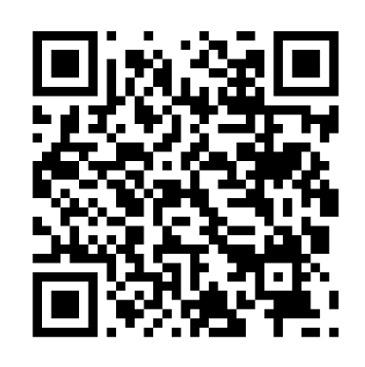
 For questions or assistance, call Brie at the NMRE (833) 285-0050

