READING STARTER KIT:

A. The CMH General Fund Contract
https://www.michigan.gov/mdhhs/keep-mi-healthy/mentalhealth/mentalhealth/cmhsp

B. The PIHP Medicaid Contract
https://www.michigan.gov/mdhhs/doing-business/contractor

C. Medicaid Provider Manual (start with BH section)
https://www.michigan.gov/mdhhs/doing-business/providers/providers/medicaid/policyforms/medicaid-provider-manual

D. Chapter 2 Mental Health Code (good place to start)
https://www.legislature.mi.gov/(S(fl0xh2rkacflj3utyjkpvw45))/documents/mcl/pdf/mcl-258-1974-2.pdf

E. CMH Administrative Rules R 330.2005-10099
https://www.michigan.gov/-/media/Project/Websites/mdhhs/Folder3/Folder96/Folder2/Folder196/Folder1/Folder296/Administrative_Rules.pdf?rev=631ae5763c904b87b36e54ae238a141a

F. 2 CFR 200 (including definitions)
https://www.ecfr.gov/current/title-2/subtitle-A/chapter-II/part-200

G. 42 CFR part 431, 433, 440, 457, and 495 [CMS 2393-p] RIN 0938-AT50 Medicaid Fiscal Accountability Regulations.
https://www.govinfo.gov/content/pkg/FR-2016-05-06/pdf/2016-09581.pdf

H. State Plan Amendment
https://www.mdch.state.mi.us/dch-medicaid/manuals/MichiganStatePlan/MichiganStatePlan.pdf

I. Michigan Waivers
https://www.medicaid.gov/medicaid/section-1115-demo/demonstration-and-waiver-list/index.html?f%5B0%5D=waiver_state_facet%3A806#content

J. Federal Contracting
https://www.acquisition.gov/browse/index/far

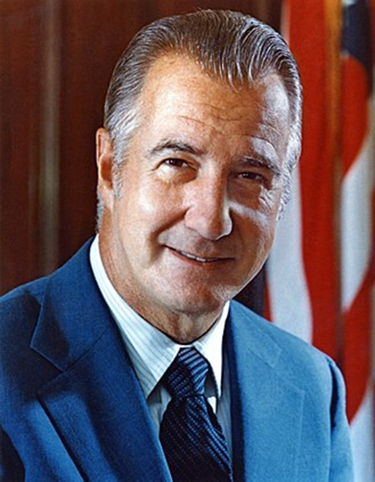

Don’t be this guy: Spiro Agnew

In 1973, Agnew Was Investigated by the United State Attorney for the District of Maryland on Suspicion of Criminal Conspiracy, bribery, extortion, and Tax Fraud.
Agnew took Kickbacks from contractors during his time as Baltimore county executive and governor of Maryland.

Federally Allowed Types of Procurement
https://www.acquisition.gov/far/part-6#FAR_Subpart_6_3

Full and Open Competition

Full and Open Competition After Exclusion of Sources
policies and procedures for providing for full and open competition after excluding one or more sources.

Policy.
Acquisitions made under this subpart require use of the competitive procedures prescribed in Full and Open Competition

Other Than Full and Open Competition
- When the supplies or services required by the agency are available from only one responsible source
- Unusual and compelling urgency.
- Industrial mobilization; engineering, developmental, or research capability; or expert services.
- International agreement.
- Authorized or required by statute.
- National security.
- Public interest.

How to establish rates:

Request for Information (RFI)
An RFI can be used to gather information about products or services that a buyer needs. Additionally, a seller or contractor can use it to get additional information for a bid. A request for information (RFI) is an organized and formal request for the information necessary to complete a purchase or fulfill a contract.

Request for Quote (RFQ)
A process wherein an enterprise asks a set of potential suppliers or service providers to submit their price quotations and stand a chance to supply or provide goods or services.

Request for Proposal (Competitive)
A procurement document that announces and describes a project or purchase request. Nearly all government agencies and many private companies use RFPs in their procurement process.

Rate Establishment/Budget (Discussion)

Types of Contracts Per F.A.R.
The Federal Acquisition Regulation is the principal set of rules regarding government procurement in the United States. This set of rules covers many of the contracts issued by the U.S. military and NASA, as well as U.S. civilian federal agencies. The government uses federal contracts as a procurement mechanism to purchase goods or services from contractors. These contracts are governed by a strict set of terms and conditions, including clauses from the FAR. Below, the definitions of different types of contracts are highlighted from part 16 of the FAR:

1. Fixed-Price Contracts
Fixed-price types of contracts provide for a firm price or, in appropriate cases, an adjustable price. Fixed-price contracts providing for an adjustable price may include a ceiling price, a target price (including target cost), or both.

2. Cost-Reimbursement Contracts
Cost-reimbursement types of contracts provide for payment of allowable incurred costs, to the extent prescribed in the contract. These contracts establish an estimate of total cost for the purpose of obligating funds and establishing a ceiling that the contractor may not exceed (except at its own risk) without the approval of the contracting officer.

3. Incentive Contracts
Incentive contracts are appropriate when a firm-fixed-price contract is not appropriate and the required supplies or services can be acquired at lower costs and, in certain instances, with improved delivery or technical performance, by relating the amount of profit or fee payable under the contract to the contractor’s performance.

4. Indefinite-Delivery Contracts
The appropriate type of indefinite-delivery contract may be used to acquire supplies and/or services when the exact times and/or exact quantities of future deliveries are not known at the time of contract award.
- Definite-Quantity Contracts: Provides for delivery of a definite quantity of specific supplies or services for a fixed period, with deliveries or performance to be scheduled at designated locations upon order.
- Requirements Contracts: A requirements contract provides for filling all actual purchase requirements of designated Government activities for supplies or services during a specified contract period (from one contractor), with deliveries or performance to be scheduled by placing orders with the contractor.
- Indefinite-Quantity Contracts: Provides for an indefinite quantity, within stated limits, of supplies or services during a fixed period. The Government places orders for individual requirements. Quantity limits may be stated as number of units or as dollar values.

5. Time-and-Materials, Labor-Hour, and Letter Contracts
- Time-and-Materials: A contract that provides for acquiring supplies or services on the basis of direct labor hours at specified fixed hourly rates that include wages, overhead, general and administrative expenses, profit, and the actual cost for materials.
- Labor-Hour Contract: A variation of the time-and-materials contract, differing only in that materials are not supplied by the contractor.
- Letter Contract: A written preliminary contractual instrument that authorizes the contractor to begin immediately manufacturing supplies or performing services.

6. Agreements
- Basic Agreements: A written instrument of understanding, negotiated between an agency or contracting activity and a contractor, that;
  - Contains contract clauses applying to future contracts between the parties during its term
  - Contemplates separate future contracts that will incorporate by reference or attachment the required and applicable clauses agreed upon in the basic agreement. A basic agreement is not a contract.
- Basic Ordering Agreement: A written instrument of understanding, negotiated between an agency, contracting activity, or contracting office and a contractor, that contains:
  - Terms and clauses applying to future contracts (orders) between the parties during its term.
  - A description, as specific as practicable, of supplies or services to be provided.
  - Methods for pricing, issuing, and delivering future orders under the basic ordering agreement. A basic ordering agreement is not a contract.

